Weekly Journal: Benchmarking Multimodal GPU Workloads
This week, I focused on benchmarking and analyzing the performance characteristics of multimodal inference workloads on a single NVIDIA A100 GPU. Specifically, I compared text translation and audio transcription workloads using Qwen2.5-7B and Qwen2-Audio-7B respectively.
The primary objective of this work was to establish clean, isolated performance baselines for each modality. Before exploring GPU multiplexing or concurrent execution strategies, it was necessary to understand how each workload behaves independently in terms of latency, variability, and initialization overhead.

Text Translation Benchmarking
I first evaluated text translation performance. The results showed that translation requests are extremely fast and stable, with each request completing in roughly 30–50 milliseconds.
One key observation was the absence of a warm-up or cold-start penalty. The very first request was processed just as quickly as subsequent ones, indicating that model initialization and CUDA kernel setup either occur almost instantaneously or contribute negligibly to total inference time.
Latency remained nearly constant across all requests, with only minor fluctuations on the order of 1 millisecond. This level of predictability suggests that text translation behaves almost like a constant-time operation from a systems perspective. As a result, text workloads are well-suited for on-demand execution, dynamic scheduling, or serverless deployment models.

Audio Transcription Benchmarking
I then analyzed audio transcription performance, which exhibited fundamentally different behavior.
The most significant finding was a large cold-start penalty on the very first request. The initial transcription took approximately 23 seconds, far exceeding any latency observed in text translation. This delay is attributed to heavy model initialization, CUDA kernel compilation, and audio-specific preprocessing pipelines.
Importantly, this cold-start cost is incurred once per worker lifecycle, not per request. After initialization, performance stabilized quickly, with subsequent transcription requests completing in approximately 500 milliseconds to 1.5 seconds, depending on audio duration.
This behavior indicates that audio transcription services cannot be spun up on demand without severely impacting user experience. Instead, they must run on persistent GPU workers so that the cold-start cost is amortized over many requests.

Cross-Modal Latency Comparison
When comparing both workloads on the same timeline, the contrast was clear. Text translation requests were tightly clustered near the origin, completing almost immediately and consuming minimal GPU time. In contrast, audio transcription requests occupied significantly more wall-clock time and extended the total runtime beyond one minute.
This highlights a fundamental asymmetry: text requests are cheap and frequent, while audio requests are expensive and long-running. Treating them identically at the scheduling level would lead to inefficient GPU utilization.

Latency Variance Analysis
I also examined latency variance across requests. Audio transcription showed high variability, with a wide distribution and long upper tails caused by differences in audio length and the presence of initialization outliers. These outliers significantly skew average latency if not handled carefully.
In contrast, text translation latency was almost invariant, forming a nearly flat distribution. This confirms that translation latency is largely insensitive to small variations in input size and highly reliable from a performance standpoint.
From a systems design perspective, this implies that audio workloads require careful buffering and scheduling, whereas text workloads can be handled opportunistically.

Key Takeaways and Next Direction
Overall, this benchmarking study led to several important conclusions:
- Audio transcription workloads must run on persistent GPU workers to avoid severe cold-start delays.
- Text translation workloads are lightweight, predictable, and flexible, making them suitable for serverless or on-demand execution.
- Most importantly, text requests can likely be interleaved into idle or waiting periods during audio processing, potentially improving overall GPU utilization without negatively impacting latency guarantees.
This work establishes a solid baseline for future exploration of GPU multiplexing and multimodal scheduling strategies, which I plan to investigate next.

Audio.py
from vllm import LLM, SamplingParams
import os
import glob
import soundfile as sf
import numpy as np
import json
import pandas as pd
import matplotlib.pyplot as plt
import seaborn as sns
import time

AUDIO_DATA_DIR = "/scratch/users/ntu/es0001an/vllm_speech_translation/audio_benchmark"

def load_local_dataset(num_samples=50):
"""Load FLAC/WAV files directly from local disk"""
print(f">>> Loading audio from {AUDIO_DATA_DIR}...")

# Find files
files = glob.glob(os.path.join(AUDIO_DATA_DIR, "*.flac")) + \
glob.glob(os.path.join(AUDIO_DATA_DIR, "*.wav"))
files.sort()

if not files:
print(">>> CRITICAL: No audio files found!")
return [], []

# Limit to num_samples
files = files[:num_samples]

audio_paths = []
audio_metadata = []

for path in files:
try:
# We just read metadata here for the log
info = sf.info(path)
audio_paths.append(path)
audio_metadata.append({"path": path, "duration": info.duration})
except: pass

print(f">>> Successfully loaded {len(audio_paths)} local audio files.")
return audio_paths, audio_metadata

def plot_audio_results(results, worker_name="Audio"):
"""Generate plots"""
if not results: return
print(f">>> Generating plots for {worker_name} worker...")

df = pd.DataFrame(results)
sns.set_theme(style="whitegrid")

plt.figure(figsize=(12, 7))
sns.histplot(df['inference_time'] * 1000, kde=True, bins=20, color='skyblue')
plt.title(f'Distribution of Inference Time - {worker_name}')
plt.xlabel('Inference Time (ms)')
plt.savefig(f'audio_inference_distribution_{worker_name.lower()}.png')
plt.close()

plt.figure(figsize=(12, 7))
# Add an index column for the timeline plot
df_sorted = df.sort_values('timestamp').reset_index(drop=True)
df_sorted['request_index'] = df_sorted.index
sns.lineplot(data=df_sorted, x='request_index', y='inference_time', color='green')
plt.title(f'Inference Time Over Sequence - {worker_name}')
plt.savefig(f'audio_inference_timeline_{worker_name.lower()}.png')
plt.close()

def main():
MODEL_PATH = "Qwen/Qwen2-Audio-7B-Instruct"
print(">>> AUDIO WORKER STARTED")

audio_paths, audio_metadata = load_local_dataset(num_samples=50)
if not audio_paths: return

#Initialize vLLM
llm = LLM(
model=MODEL_PATH,
trust_remote_code=True,
enforce_eager=True,
max_model_len=3920,
gpu_memory_utilization=0.9,
limit_mm_per_prompt={"audio": 1},
enable_mm_embeds=True,
)

results = []
sampling_params = SamplingParams(temperature=0.7, max_tokens=128)

print("\n>>> Processing audio files...")
start_time = time.time()

for idx, (path, meta) in enumerate(zip(audio_paths, audio_metadata)):
try:
prompt = "<|im_start|>system\nYou are a helpful assistant.<|im_end|>\n<|im_start|>user\nAudio 1: <|audio_bos|><|AUDIO|><|audio_eos|>\nTranscribe the audio.<|im_end|>\n<|im_start|>assistant\n"

# Instead of passing the path string (which crashes vLLM's parser),
# we load the audio into a numpy array ourselves and pass the raw data.
audio_data, sample_rate = sf.read(path)

# vLLM expects a tuple of (numpy_array, sample_rate)
inputs = {
"prompt": prompt,
"multi_modal_data": {
"audio": (audio_data, sample_rate)
}
}

req_start = time.time()
outputs = llm.generate(inputs, sampling_params=sampling_params)
inference_time = time.time() - req_start

transcription = outputs[0].outputs[0].text

results.append({
"audio_file": os.path.basename(path),
"transcription": transcription,
"audio_duration": meta["duration"],
"inference_time": inference_time,
"timestamp": time.time(),
"success": True
})

if (idx+1) % 10 == 0:
print(f">>> Processed {idx+1}/{len(audio_paths)}")

except Exception as e:
print(f"Error processing {path}: {e}")

total_time = time.time() - start_time

with open("audio_benchmark_results.json", "w") as f:
json.dump(results, f, indent=4)

plot_audio_results(results)
print(f">>> Audio Worker Finished. Total time: {total_time:.2f}s")

if results:
print("\n>>> Sample Transcription:")
print(f"File: {results[0]['audio_file']}")
print(f"Text: {results[0]['transcription']}")

if __name__ == "__main__":
os.environ['VLLM_WORKER_MULTIPROC_METHOD'] = 'spawn'
main()

benchaudio.sh
#!/bin/bash
#PBS -N Audio-Trans-Sequential
#PBS -l select=1:ngpus=1:mem=110gb
#PBS -l walltime=02:30:00
#PBS -j oe
#PBS -P personal-es0001an
#PBS -q normal
#PBS -M estherleeyishan@gmail.com
#PBS -m abe

cd $PBS_O_WORKDIR

# Environment Setup
source /app/apps/miniforge3/25.3.1/etc/profile.d/conda.sh
conda activate /scratch/users/ntu/es0001an/vllm_speech_translation/vllm_env

# Exports
export HF_HOME=/scratch/users/ntu/es0001an/hf_cache
export TORCH_HOME=/scratch/users/ntu/es0001an/torch_cache
export VLLM_WORKER_MULTIPROC_METHOD=spawn
export CUDA_VISIBLE_DEVICES=0

# Disable Torch Compile
export VLLM_COMPILE_MODE=eager
export TORCH_COMPILE_DISABLE=1
export MPLBACKEND=Agg

echo ">>> Starting Sequential GPU Multiplexing Benchmark at $(date)"
echo "============================================================"
echo ">>> Environment Check:"
echo " - Python: $(which python)"
echo " - CUDA Visible Devices: $CUDA_VISIBLE_DEVICES"
echo " - HF_HOME: $HF_HOME"
echo ">>> GPU Status:"
nvidia-smi --query-gpu=name,memory.total,memory.free --format=csv
echo "============================================================"

# Launch translation first, wait for it to initialize, then launch audio
# This avoids simultaneous vLLM initialization conflicts

echo ""
echo ">>> STEP 1: Launching Translation Worker..."
python -u translation_worker.py > translation_log.txt 2>&1 &
TRANS_PID=$!

echo ">>> Translation Worker PID: $TRANS_PID"
echo ">>> Waiting 90 seconds for Translation Worker to initialize and allocate GPU memory..."

# Wait and monitor
for i in {1..9}; do
sleep 10
if ! kill -0 $TRANS_PID 2>/dev/null; then
echo ">>> WARNING: Translation worker died at ${i}0s!"
break
fi

GPU_MEM=$(nvidia-smi --query-gpu=memory.used --format=csv,noheader,nounits)
echo ">>> ${i}0s: Translation alive, GPU memory: ${GPU_MEM} MiB"

# If GPU memory > 10GB, translation has initialized
if [ "$GPU_MEM" -gt 10000 ]; then
echo ">>> Translation worker initialized (GPU memory allocated)!"
break
fi
done

# Check if translation is still running
if ! kill -0 $TRANS_PID 2>/dev/null; then
echo ""
echo ">>> ERROR: Translation worker failed during initialization!"
echo ">>> Translation log:"
cat translation_log.txt
exit 1
fi

echo ""
echo ">>> Current GPU status:"
nvidia-smi --query-gpu=memory.used,memory.free --format=csv
echo ""

echo ">>> STEP 2: Launching Audio Worker..."
python -u audiov0110multis.py > audio_log.txt 2>&1 &
AUDIO_PID=$!

echo ">>> Audio Worker PID: $AUDIO_PID"
echo ">>> Both workers now running..."
echo ""

# Monitor both workers
monitor_interval=15
while kill -0 $TRANS_PID 2>/dev/null || kill -0 $AUDIO_PID 2>/dev/null; do
sleep $monitor_interval

TRANS_STATUS="DEAD"
AUDIO_STATUS="DEAD"
kill -0 $TRANS_PID 2>/dev/null && TRANS_STATUS="RUNNING"
kill -0 $AUDIO_PID 2>/dev/null && AUDIO_STATUS="RUNNING"

GPU_UTIL=$(nvidia-smi --query-gpu=utilization.gpu --format=csv,noheader,nounits)
GPU_MEM=$(nvidia-smi --query-gpu=memory.used --format=csv,noheader,nounits)

echo ">>> Status: Trans=$TRANS_STATUS | Audio=$AUDIO_STATUS | GPU=${GPU_UTIL}% | Mem=${GPU_MEM}MiB"

# Exit if both done
if [ "$TRANS_STATUS" = "DEAD" ] && [ "$AUDIO_STATUS" = "DEAD" ]; then
break
fi
done

# Wait for completion
wait $TRANS_PID
TRANS_EXIT=$?

wait $AUDIO_PID
AUDIO_EXIT=$?

echo ""
echo ">>> Translation worker exit code: $TRANS_EXIT"
echo ">>> Audio worker exit code: $AUDIO_EXIT"
echo ">>> Benchmark completed at $(date)"
echo ""

# Display logs
echo "=========================================="
echo "=== Translation Log (last 30 lines) ==="
echo "=========================================="
tail -n 30 translation_log.txt

echo ""
echo "======================================="
echo "=== Audio Log (last 30 lines) ==="
echo "======================================="
tail -n 30 audio_log.txt

# Generate comparison if both succeeded
echo ""
if [ $TRANS_EXIT -eq 0 ] && [ $AUDIO_EXIT -eq 0 ]; then
echo ">>> SUCCESS! Both workers completed."
echo ">>> Generating comparison plots..."
python -u plot_multiplex_comparison.py

echo ""
echo "=== Generated Files ==="
ls -lh *benchmark*.json *.png 2>/dev/null | head -20
else
echo ">>> FAILURE: One or both workers failed"
echo ">>> Translation exit: $TRANS_EXIT"
echo ">>> Audio exit: $AUDIO_EXIT"
fi

echo ""
echo "=== Final GPU Status ==="
nvidia-smi

exit 0

plotmultiple.py
import json
import numpy as np
import pandas as pd
import matplotlib.pyplot as plt
import seaborn as sns

def load_results():
"""Load results from both workers"""
audio_results = None
translation_results = None

try:
with open("audio_benchmark_results.json", "r") as f:
audio_results = json.load(f)
print(f"Loaded {len(audio_results)} audio results")
except FileNotFoundError:
print("Warning: audio_benchmark_results.json not found")

try:
with open("translation_benchmark_results.json", "r") as f:
translation_results = json.load(f)
print(f"Loaded {len(translation_results)} translation results")
except FileNotFoundError:
print("Warning: translation_benchmark_results.json not found")

return audio_results, translation_results

def plot_side_by_side_comparison(audio_results, translation_results):
"""Create side-by-side comparison plots"""

if not audio_results or not translation_results:
print("Cannot create comparison - missing data")
return

sns.set_theme(style="whitegrid")

# Latency Comparison (Side by Side)
fig, (ax1, ax2) = plt.subplots(1, 2, figsize=(16, 6))

# Audio inference times
audio_df = pd.DataFrame(audio_results)
audio_times_ms = audio_df['inference_time'] * 1000
ax1.hist(audio_times_ms, bins=50, color='skyblue', alpha=0.7, edgecolor='black')
ax1.set_title('Audio Worker - Inference Time Distribution', fontsize=14, fontweight='bold')
ax1.set_xlabel('Inference Time (ms)')
ax1.set_ylabel('Frequency')
ax1.axvline(audio_times_ms.mean(), color='red', linestyle='--', linewidth=2, label=f'Mean: {audio_times_ms.mean():.2f}ms')
ax1.legend()

# Translation TTFT
trans_df = pd.DataFrame(translation_results)
ax2.hist(trans_df['ttft'], bins=50, color='coral', alpha=0.7, edgecolor='black')
ax2.set_title('Translation Worker - TTFT Distribution', fontsize=14, fontweight='bold')
ax2.set_xlabel('Time to First Token (ms)')
ax2.set_ylabel('Frequency')
ax2.axvline(trans_df['ttft'].mean(), color='red', linestyle='--', linewidth=2, label=f'Mean: {trans_df["ttft"].mean():.2f}ms')
ax2.legend()

plt.tight_layout()
plt.savefig('multiplex_latency_comparison.png', dpi=300)
print(">>> Saved multiplex_latency_comparison.png")
plt.close()

# Timeline Overlay (Both workers over time)
fig, ax = plt.subplots(figsize=(14, 7))

# Normalize timestamps to start from 0
audio_df_sorted = audio_df.sort_values('timestamp')
trans_df_sorted = trans_df.sort_values('timestamp')

audio_start = audio_df_sorted['timestamp'].min()
trans_start = trans_df_sorted['timestamp'].min()
overall_start = min(audio_start, trans_start)

audio_df_sorted['relative_time'] = audio_df_sorted['timestamp'] - overall_start
trans_df_sorted['relative_time'] = trans_df_sorted['timestamp'] - overall_start

# Plot both
ax.scatter(audio_df_sorted['relative_time'], audio_df_sorted['inference_time'],
alpha=0.6, s=50, color='skyblue', label='Audio Worker', marker='o')
ax.scatter(trans_df_sorted['relative_time'], trans_df_sorted['latency'],
alpha=0.6, s=50, color='coral', label='Translation Worker', marker='s')

ax.set_title('GPU Multiplexing: Both Workers Timeline', fontsize=16, fontweight='bold')
ax.set_xlabel('Time from Start (seconds)')
ax.set_ylabel('Latency (seconds)')
ax.legend(fontsize=12)
ax.grid(True, alpha=0.3)

plt.tight_layout()
plt.savefig('multiplex_timeline_overlay.png', dpi=300)
print(">>> Saved multiplex_timeline_overlay.png")
plt.close()

# Summary Statistics Table
fig, ax = plt.subplots(figsize=(12, 6))
ax.axis('tight')
ax.axis('off')

audio_inference_ms = audio_df['inference_time'] * 1000
trans_ttft = trans_df['ttft']
trans_latency = trans_df['latency']

table_data = [
["Metric", "Audio Worker", "Translation Worker"],
["Number of Requests", f"{len(audio_df)}", f"{len(trans_df)}"],
["Mean Latency", f"{audio_inference_ms.mean():.2f} ms", f"{trans_ttft.mean():.2f} ms"],
["Median Latency", f"{audio_inference_ms.median():.2f} ms", f"{trans_ttft.median():.2f} ms"],
["P99 Latency", f"{np.percentile(audio_inference_ms, 99):.2f} ms", f"{np.percentile(trans_ttft, 99):.2f} ms"],
["Min Latency", f"{audio_inference_ms.min():.2f} ms", f"{trans_ttft.min():.2f} ms"],
["Max Latency", f"{audio_inference_ms.max():.2f} ms", f"{trans_ttft.max():.2f} ms"],
["Std Dev", f"{audio_inference_ms.std():.2f} ms", f"{trans_ttft.std():.2f} ms"],
]

table = ax.table(cellText=table_data, cellLoc='center', loc='center',
colWidths=[0.3, 0.35, 0.35])
table.auto_set_font_size(False)
table.set_fontsize(11)
table.scale(1, 2)

# Style header row
for i in range(3):
table[(0, i)].set_facecolor('#4CAF50')
table[(0, i)].set_text_props(weight='bold', color='white')

# Alternate row colors
for i in range(1, len(table_data)):
for j in range(3):
if i % 2 == 0:
table[(i, j)].set_facecolor('#f0f0f0')

plt.title('GPU Multiplexing Benchmark - Summary Statistics',
fontsize=16, fontweight='bold', pad=20)
plt.savefig('multiplex_summary_table.png', dpi=300, bbox_inches='tight')
print(">>> Saved multiplex_summary_table.png")
plt.close()

# Box Plot Comparison
fig, ax = plt.subplots(figsize=(10, 7))

combined_data = pd.DataFrame({
'Latency (ms)': list(audio_inference_ms) + list(trans_ttft),
'Worker': ['Audio']*len(audio_inference_ms) + ['Translation']*len(trans_ttft)
})

sns.boxplot(data=combined_data, x='Worker', y='Latency (ms)',
palette={'Audio': 'skyblue', 'Translation': 'coral'}, ax=ax)
ax.set_title('Latency Distribution Comparison', fontsize=16, fontweight='bold')
ax.set_ylabel('Latency (ms)', fontsize=12)
ax.set_xlabel('Worker Type', fontsize=12)

plt.tight_layout()
plt.savefig('multiplex_boxplot_comparison.png', dpi=300)
print(">>> Saved multiplex_boxplot_comparison.png")
plt.close()

def print_comparison_summary(audio_results, translation_results):
"""Print detailed comparison statistics"""

if not audio_results or not translation_results:
print("Cannot create summary - missing data")
return

audio_df = pd.DataFrame(audio_results)
trans_df = pd.DataFrame(translation_results)

audio_times = audio_df['inference_time'].values
trans_times = trans_df['latency'].values

print("\n" + "="*80)
print("GPU MULTIPLEXING BENCHMARK - COMPARISON SUMMARY")
print("="*80)
print(f"\nAudio Worker:")
print(f" Total requests: {len(audio_df)}")
print(f" Mean inference time: {np.mean(audio_times)*1000:.2f} ms")
print(f" Median inference time: {np.median(audio_times)*1000:.2f} ms")
print(f" P99 inference time: {np.percentile(audio_times*1000, 99):.2f} ms")
print(f" Total audio duration: {audio_df['audio_duration'].sum():.2f} s")

print(f"\nTranslation Worker:")
print(f" Total requests: {len(trans_df)}")
print(f" Mean TTFT: {trans_df['ttft'].mean():.2f} ms")
print(f" Median TTFT: {trans_df['ttft'].median():.2f} ms")
print(f" P99 TTFT: {np.percentile(trans_df['ttft'], 99):.2f} ms")
print(f" Mean total latency: {trans_df['latency'].mean():.3f} s")

# Check for temporal overlap
audio_start = audio_df['timestamp'].min()
audio_end = audio_df['timestamp'].max()
trans_start = trans_df['timestamp'].min()
trans_end = trans_df['timestamp'].max()

overlap_start = max(audio_start, trans_start)
overlap_end = min(audio_end, trans_end)
overlap_duration = max(0, overlap_end - overlap_start)

print(f"\nTemporal Analysis:")
print(f" Audio worker duration: {audio_end - audio_start:.2f} s")
print(f" Translation duration: {trans_end - trans_start:.2f} s")
print(f" Overlap duration: {overlap_duration:.2f} s")
print(f" Overlap percentage: {(overlap_duration / max(audio_end-audio_start, trans_end-trans_start)) * 100:.1f}%")

print("\n" + "="*80)

if __name__ == "__main__":
print("Loading benchmark results...")
audio_results, translation_results = load_results()

if audio_results and translation_results:
print("\nGenerating comparison plots...")
plot_side_by_side_comparison(audio_results, translation_results)

print("\nGenerating comparison summary...")
print_comparison_summary(audio_results, translation_results)

print("\nAll comparison plots and statistics generated successfully!")
else:
print("\nMissing result files. Run both workers first.")

translation_worker.py
from vllm import LLM, SamplingParams
from datasets import load_dataset
import time
import os
import json
import numpy as np
import pandas as pd
import matplotlib.pyplot as plt
import seaborn as sns

def plot_translation_results(results, worker_name="Translation"):
"""Generate comprehensive plots for translation results"""
if not results:
print("No successful results to plot.")
return

print(f">>> Generating plots for {worker_name} worker...")
df = pd.DataFrame(results)

sns.set_theme(style="whitegrid")

# Time to First Token (TTFT) Distribution
plt.figure(figsize=(12, 7))
sns.histplot(df['ttft'], kde=True, bins=50, color='skyblue')
plt.title(f'Distribution of Time to First Token (TTFT) - {worker_name}', fontsize=16)
plt.xlabel('Time to First Token (ms)')
plt.ylabel('Number of Requests')
plt.xlim(0, df['ttft'].quantile(0.99))
plot_file = f'translation_ttft_distribution_{worker_name.lower()}.png'
plt.savefig(plot_file)
print(f">>> Saved {plot_file}")
plt.close()

#TTFT vs Input Length
plt.figure(figsize=(12, 7))
sns.scatterplot(data=df, x='input_length', y='ttft', alpha=0.6, color='coral', s=80)
plt.title(f'TTFT vs. Input Text Length - {worker_name}', fontsize=16)
plt.xlabel('Input Text Length (characters)')
plt.ylabel('Time to First Token (ms)')
plt.ylim(0, df['ttft'].quantile(0.99) * 1.1)
plot_file = f'translation_ttft_vs_length_{worker_name.lower()}.png'
plt.savefig(plot_file)
print(f">>> Saved {plot_file}")
plt.close()

# Total Latency Distribution
plt.figure(figsize=(12, 7))
sns.histplot(df['latency'], kde=True, bins=50, color='green')
plt.title(f'Distribution of Total Latency - {worker_name}', fontsize=16)
plt.xlabel('Total Latency (seconds)')
plt.ylabel('Number of Requests')
plot_file = f'translation_latency_distribution_{worker_name.lower()}.png'
plt.savefig(plot_file)
print(f">>> Saved {plot_file}")
plt.close()

# Translation Output Length Distribution
plt.figure(figsize=(12, 7))
sns.histplot(df['output_length'], kde=True, bins=40, color='purple')
plt.title(f'Distribution of Translation Output Length - {worker_name}', fontsize=16)
plt.xlabel('Output Length (characters)')
plt.ylabel('Number of Translations')
plot_file = f'translation_output_length_{worker_name.lower()}.png'
plt.savefig(plot_file)
print(f">>> Saved {plot_file}")
plt.close()

# Throughput Over Time
plt.figure(figsize=(12, 7))
df_sorted = df.sort_values('timestamp')
df_sorted['request_index'] = range(len(df_sorted))

sns.lineplot(data=df_sorted, x='request_index', y='latency', color='blue', linewidth=2)
plt.title(f'Latency Over Processing Sequence - {worker_name}', fontsize=16)
plt.xlabel('Request Index')
plt.ylabel('Latency (seconds)')
plot_file = f'translation_latency_timeline_{worker_name.lower()}.png'
plt.savefig(plot_file)
print(f">>> Saved {plot_file}")
plt.close()

print(f">>> All plots generated for {worker_name} worker!")

def main():
# Configuration
MODEL_PATH = "Qwen/Qwen2.5-7B-Instruct"

print(f">>> [Translation Worker] Loading dataset...")

# Load WMT19 Chinese-English dataset
try:
dataset = load_dataset("wmt19", "zh-en", split="validation")
# Extract CHINESE sentences (to translate to English)
sentences = [item["translation"]["zh"] for item in dataset.select(range(min(100, len(dataset))))]
print(f">>> [Translation Worker] Loaded {len(sentences)} Chinese sentences from WMT19")
except Exception as e:
print(f">>> [Translation Worker] Failed to load WMT19: {e}")
print(">>> [Translation Worker] Falling back to sample Chinese sentences...")
# Fallback to hardcoded Chinese sentences
sentences = [
"这是一个测试句子。",
"人工智能正在改变世界。",
"请确保服务器保持凉爽和通风良好。",
"GPU多路复用可以提高效率。",
"我需要在明天之前完成这个基准测试。"
] * 20

print(f">>> [Translation Worker] Initializing {MODEL_PATH}...")

# Initialize vLLM with settings that WORKED in your successful run
llm = LLM(
model=MODEL_PATH,
tensor_parallel_size=1,
gpu_memory_utilization=0.45,
max_model_len=4096,
trust_remote_code=True,
enforce_eager=True
)

# Prepare Translation Prompts
prompts = []
for sent in sentences:
# Qwen Chat Format - translating Chinese to English
prompt = f"<|im_start|>system\nYou are a professional translator. Translate the following Chinese text into English.<|im_end|>\n<|im_start|>user\n{sent}<|im_end|>\n<|im_start|>assistant\n"
prompts.append(prompt)

sampling_params = SamplingParams(temperature=0.7, top_p=0.8, max_tokens=128)

# Run Inference
print(">>> [Translation Worker] Starting Batch Translation...")
start_time = time.time()

# Track detailed metrics for each request
detailed_results = []

# Process in batches to track individual timings
batch_size = 50
for i in range(0, len(prompts), batch_size):
batch_prompts = prompts[i:i+batch_size]
batch_sentences = sentences[i:i+batch_size]

batch_start = time.time()
batch_outputs = llm.generate(batch_prompts, sampling_params)
batch_end = time.time()

# Record metrics for each request in batch
for j, output in enumerate(batch_outputs):
result = {
"input_text": batch_sentences[j][:100] + "..." if len(batch_sentences[j]) > 100 else batch_sentences[j],
"input_length": len(batch_sentences[j]),
"output_text": output.outputs[0].text[:100] + "..." if len(output.outputs[0].text) > 100 else output.outputs[0].text,
"output_length": len(output.outputs[0].text),
"ttft": (batch_end - batch_start) * 1000 / len(batch_outputs),
"latency": (batch_end - batch_start) / len(batch_outputs),
"timestamp": batch_end,
"success": True
}
detailed_results.append(result)

print(f">>> [Translation Worker] Processed batch {i//batch_size + 1}/{(len(prompts) + batch_size - 1)//batch_size}")

end_time = time.time()
elapsed = end_time - start_time
throughput = len(prompts) / elapsed

print(f">>> [Translation Worker] Finished {len(prompts)} translations in {elapsed:.2f}s")
print(f">>> [Translation Worker] Throughput: {throughput:.2f} translations/sec")

# Calculate detailed statistics
if detailed_results:
ttfts = [r["ttft"] for r in detailed_results]
latencies = [r["latency"] for r in detailed_results]
input_lengths = [r["input_length"] for r in detailed_results]
output_lengths = [r["output_length"] for r in detailed_results]

print("\n" + "="*80)
print(">>> TRANSLATION WORKER BENCHMARK SUMMARY")
print("="*80)
print(f"Total translations: {len(detailed_results)}")
print(f"Total processing time (s): {elapsed:.2f}")
print(f"Throughput (translations/s): {throughput:.2f}")
print(f"\n---------------Time to First Token----------------")
print(f"Mean TTFT (ms): {np.mean(ttfts):.2f}")
print(f"Median TTFT (ms): {np.median(ttfts):.2f}")
print(f"P99 TTFT (ms): {np.percentile(ttfts, 99):.2f}")
print(f"Min TTFT (ms): {np.min(ttfts):.2f}")
print(f"Max TTFT (ms): {np.max(ttfts):.2f}")
print(f"\n---------------Total Latency----------------------")
print(f"Mean Latency (s): {np.mean(latencies):.3f}")
print(f"Median Latency (s): {np.median(latencies):.3f}")
print(f"P99 Latency (s): {np.percentile(latencies, 99):.3f}")
print(f"\n---------------Input/Output Statistics------------")
print(f"Mean input length (chars): {np.mean(input_lengths):.0f}")
print(f"Mean output length (chars): {np.mean(output_lengths):.0f}")
print("="*80)

# Save results to JSON
results_filename = "translation_benchmark_results.json"
with open(results_filename, "w") as f:
json.dump(detailed_results, f, indent=4)
print(f"\n>>> Raw results saved to {results_filename}")

# Generate plots
plot_translation_results(detailed_results, "Translation")

# Print samples
print("\n>>> [Translation Worker] Sample Outputs:")
for i in range(min(3, len(detailed_results))):
print(f" Input: {detailed_results[i]['input_text']}")
print(f" Output: {detailed_results[i]['output_text']}")
print()

if __name__ == "__main__":
os.environ['VLLM_WORKER_MULTIPROC_METHOD'] = 'spawn'
main()

images:
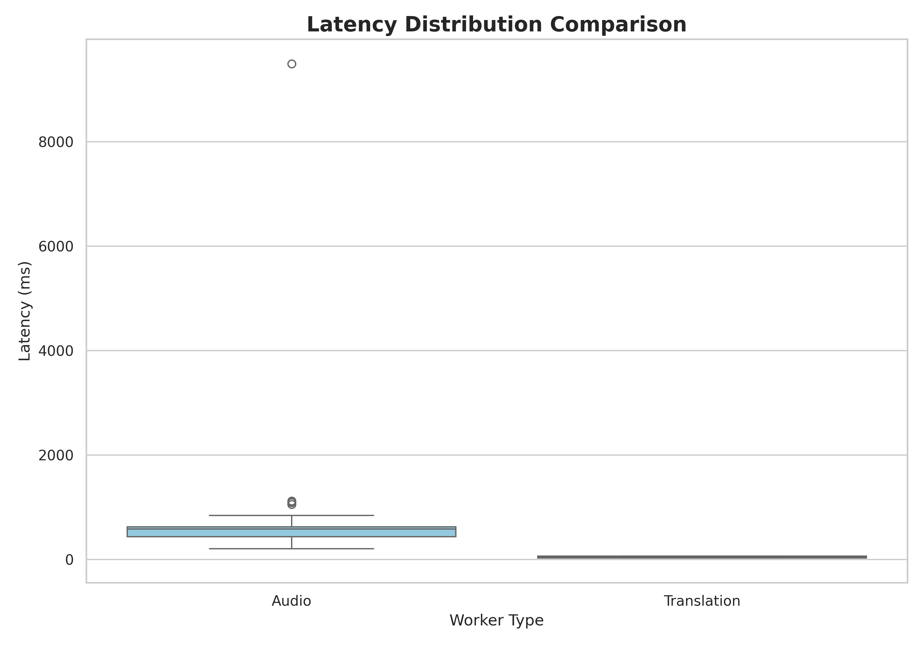
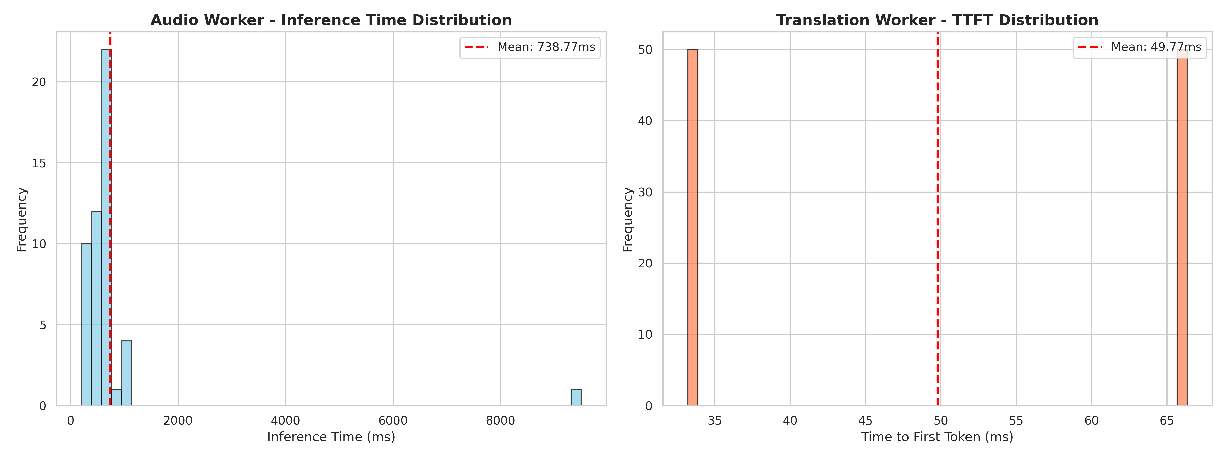
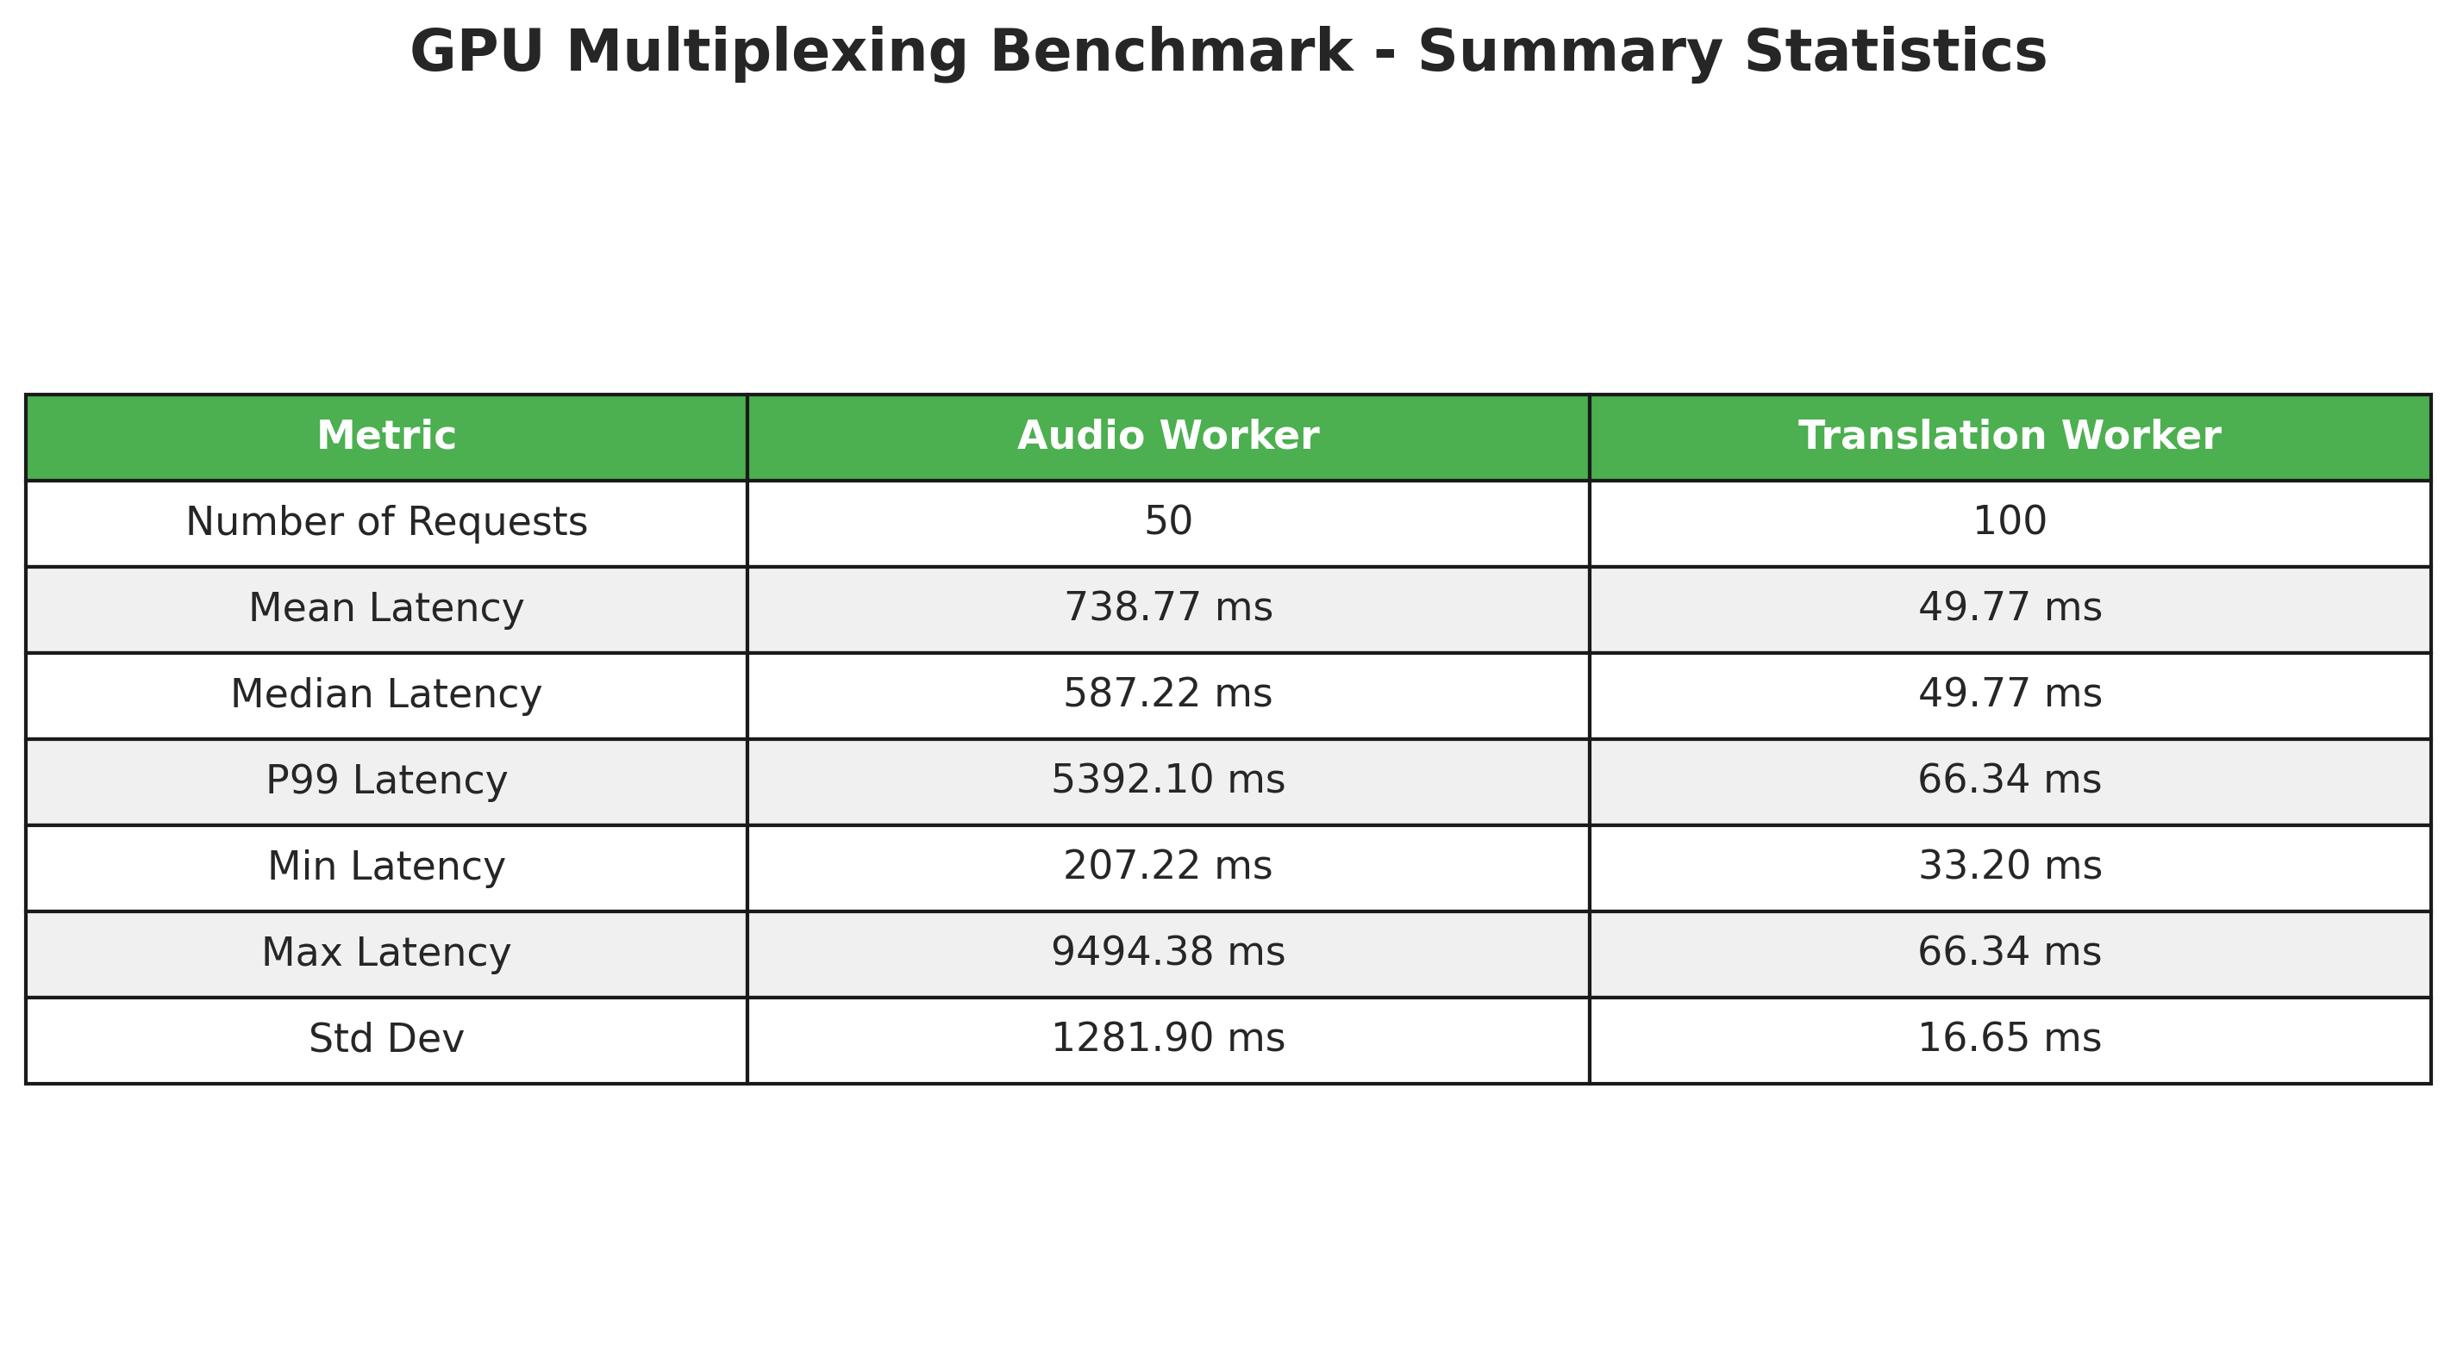
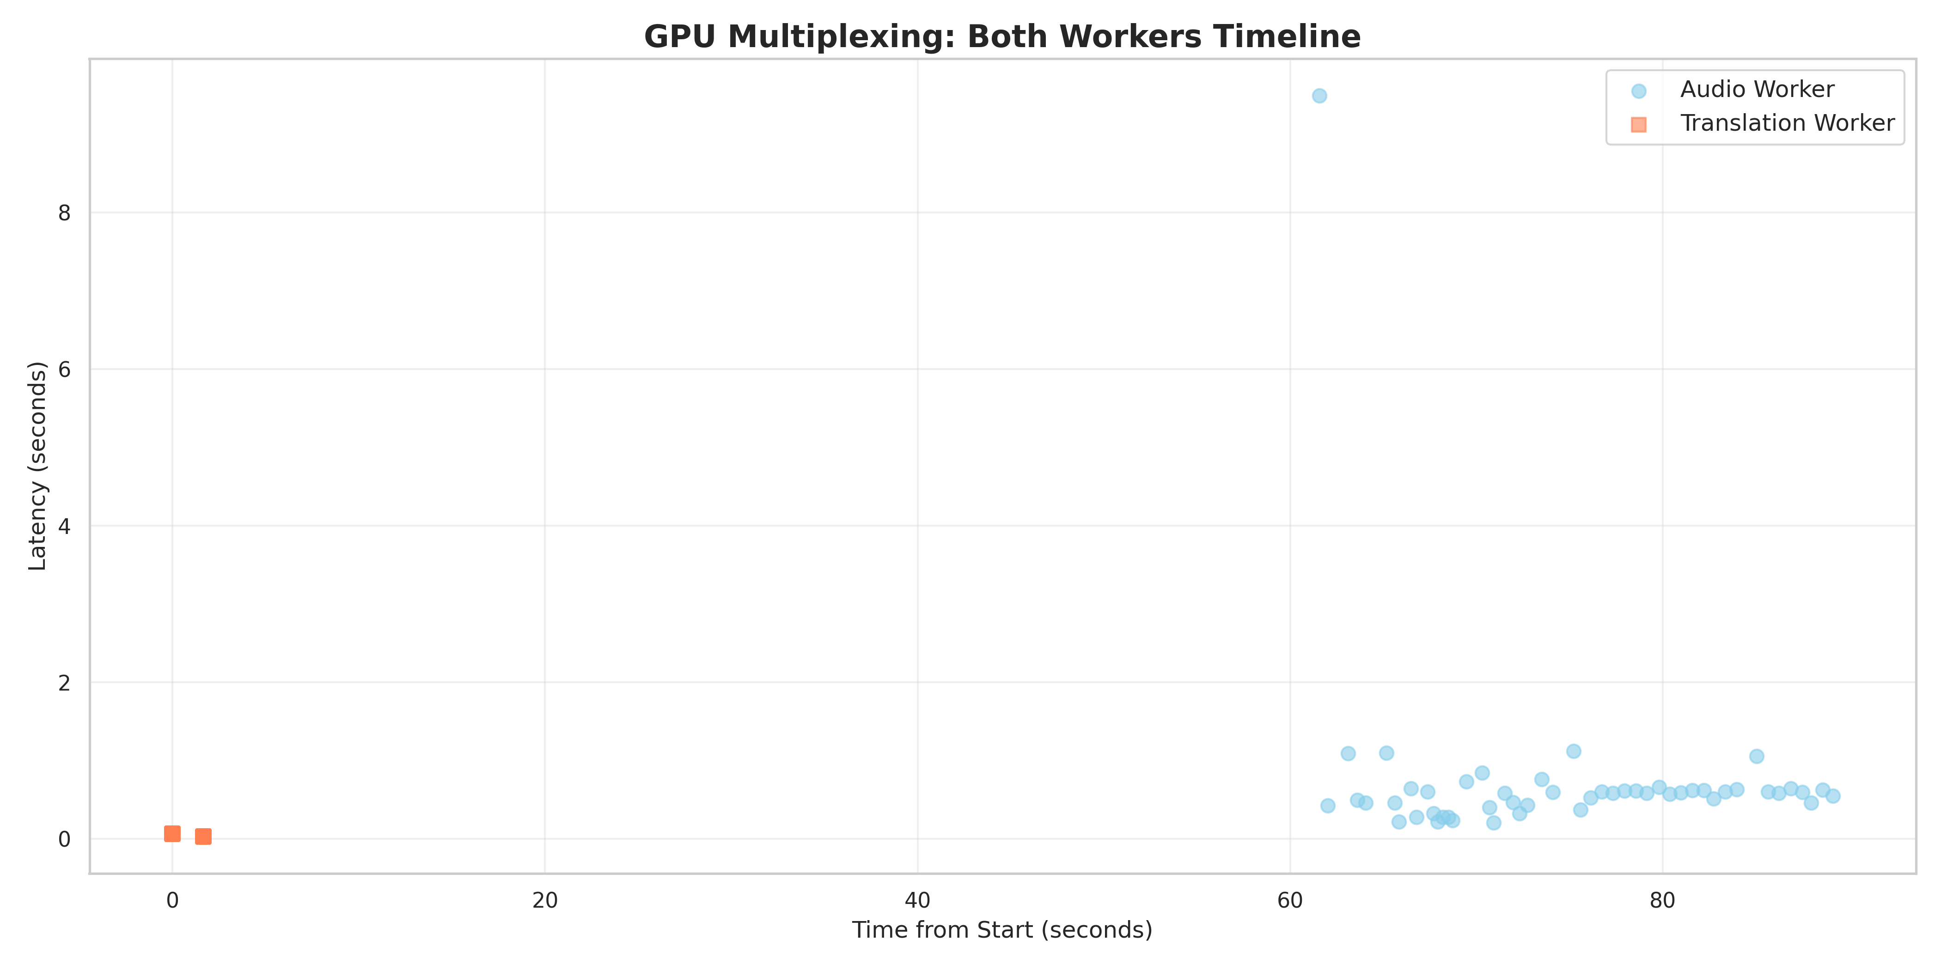
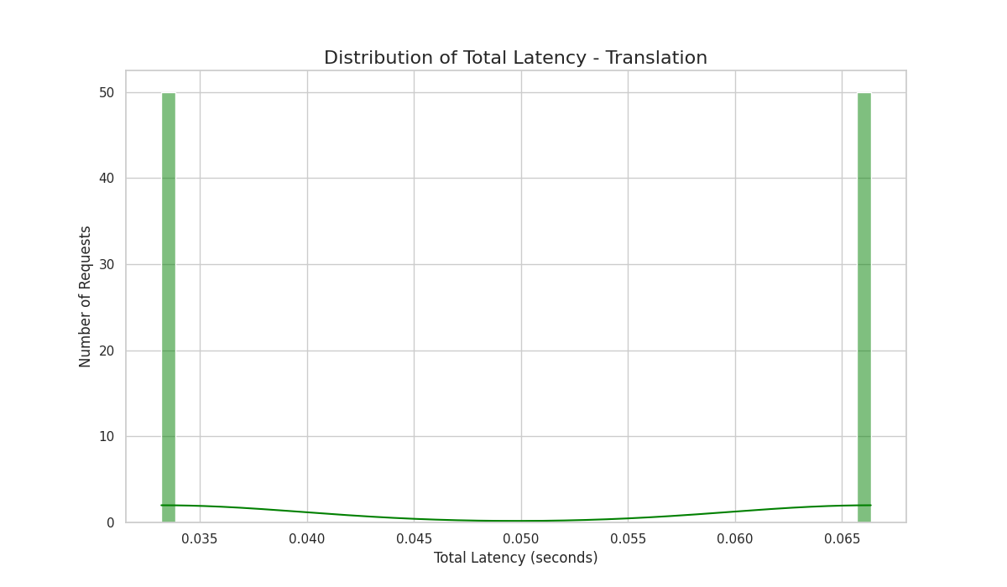
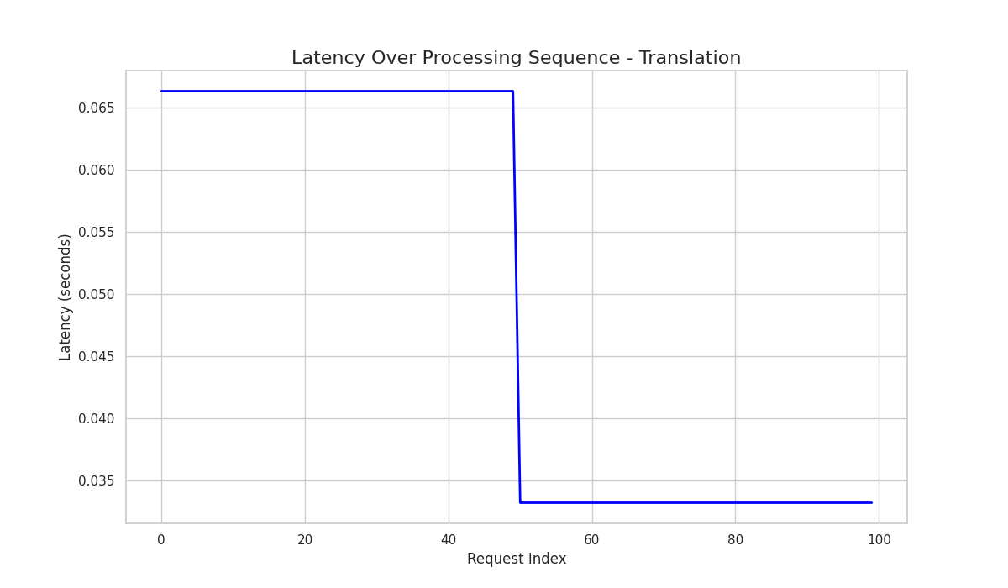
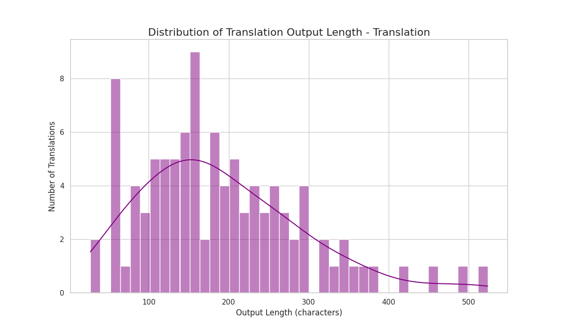
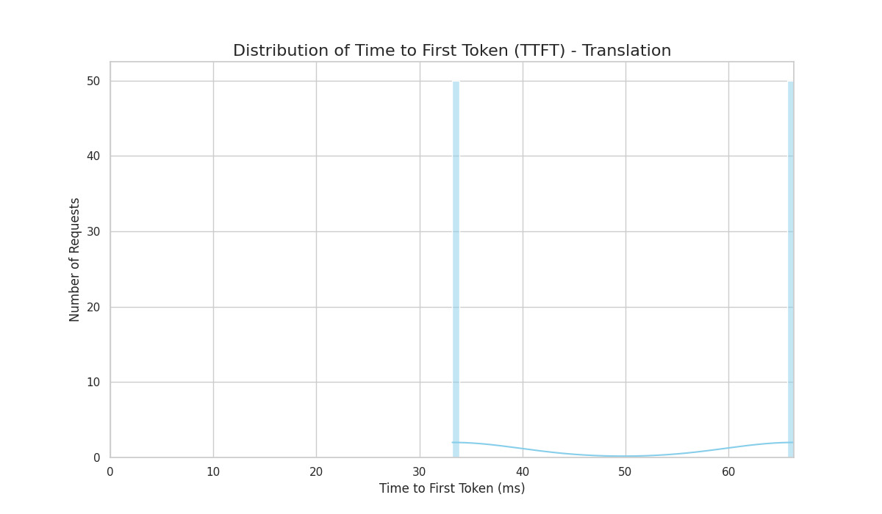
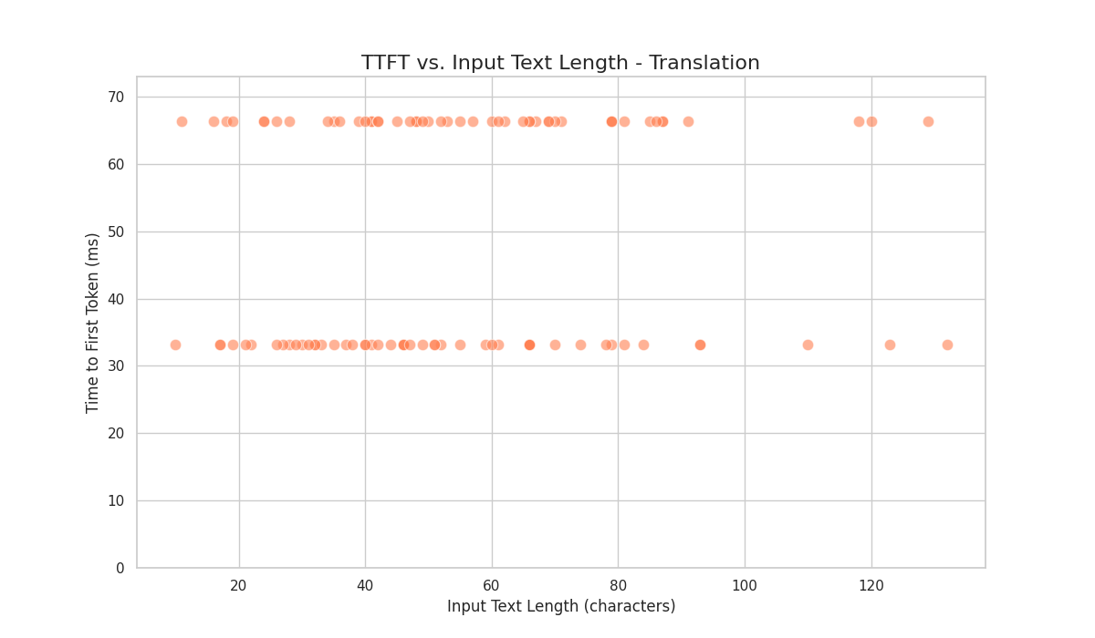
Output:
>>> Starting Sequential Benchmark at Tue Dec 16 15:51:58 +08 2025
============================================================
>>> [1/2] Running Translation Worker...
>>> [Translation Worker] Loading dataset...
>>> [Translation Worker] Loaded 100 Chinese sentences from WMT19
>>> [Translation Worker] Initializing Qwen/Qwen2.5-7B-Instruct...
INFO 12-16 15:52:19 [utils.py:253] non-default args: {'trust_remote_code': True, 'max_model_len': 4096, 'gpu_memory_utilization': 0.45, 'disable_log_stats': True, 'enforce_eager': True, 'model': 'Qwen/Qwen2.5-7B-Instruct'}
The argument `trust_remote_code` is to be used with Auto classes. It has no effect here and is ignored.
INFO 12-16 15:52:21 [model.py:631] Resolved architecture: Qwen2ForCausalLM
INFO 12-16 15:52:21 [model.py:1745] Using max model len 4096
INFO 12-16 15:52:21 [scheduler.py:216] Chunked prefill is enabled with max_num_batched_tokens=8192.
INFO 12-16 15:52:21 [vllm.py:500] Cudagraph is disabled under eager mode
[1;36m(EngineCore_DP0 pid=3910775)[0;0m INFO 12-16 15:52:31 [core.py:93] Initializing a V1 LLM engine (v0.11.2) with config: model='Qwen/Qwen2.5-7B-Instruct', speculative_config=None, tokenizer='Qwen/Qwen2.5-7B-Instruct', skip_tokenizer_init=False, tokenizer_mode=auto, revision=None, tokenizer_revision=None, trust_remote_code=True, dtype=torch.bfloat16, max_seq_len=4096, download_dir=None, load_format=auto, tensor_parallel_size=1, pipeline_parallel_size=1, data_parallel_size=1, disable_custom_all_reduce=False, quantization=None, enforce_eager=True, kv_cache_dtype=auto, device_config=cuda, structured_outputs_config=StructuredOutputsConfig(backend='auto', disable_fallback=False, disable_any_whitespace=False, disable_additional_properties=False, reasoning_parser='', reasoning_parser_plugin='', enable_in_reasoning=False), observability_config=ObservabilityConfig(show_hidden_metrics_for_version=None, otlp_traces_endpoint=None, collect_detailed_traces=None), seed=0, served_model_name=Qwen/Qwen2.5-7B-Instruct, enable_prefix_caching=True, enable_chunked_prefill=True, pooler_config=None, compilation_config={'level': None, 'mode': <CompilationMode.NONE: 0>, 'debug_dump_path': None, 'cache_dir': '', 'compile_cache_save_format': 'binary', 'backend': 'inductor', 'custom_ops': ['all'], 'splitting_ops': None, 'compile_mm_encoder': False, 'use_inductor': None, 'compile_sizes': [], 'inductor_compile_config': {'enable_auto_functionalized_v2': False, 'combo_kernels': True, 'benchmark_combo_kernel': True}, 'inductor_passes': {}, 'cudagraph_mode': <CUDAGraphMode.NONE: 0>, 'cudagraph_num_of_warmups': 0, 'cudagraph_capture_sizes': [], 'cudagraph_copy_inputs': False, 'cudagraph_specialize_lora': True, 'use_inductor_graph_partition': False, 'pass_config': {}, 'max_cudagraph_capture_size': 0, 'local_cache_dir': None}
[1;36m(EngineCore_DP0 pid=3910775)[0;0m INFO 12-16 15:52:32 [parallel_state.py:1208] world_size=1 rank=0 local_rank=0 distributed_init_method=tcp://10.150.0.31:55053 backend=nccl
[Gloo] Rank 0 is connected to 0 peer ranks. Expected number of connected peer ranks is : 0
[Gloo] Rank 0 is connected to 0 peer ranks. Expected number of connected peer ranks is : 0
[Gloo] Rank 0 is connected to 0 peer ranks. Expected number of connected peer ranks is : 0
[Gloo] Rank 0 is connected to 0 peer ranks. Expected number of connected peer ranks is : 0
[Gloo] Rank 0 is connected to 0 peer ranks. Expected number of connected peer ranks is : 0
[Gloo] Rank 0 is connected to 0 peer ranks. Expected number of connected peer ranks is : 0
[1;36m(EngineCore_DP0 pid=3910775)[0;0m INFO 12-16 15:52:32 [parallel_state.py:1394] rank 0 in world size 1 is assigned as DP rank 0, PP rank 0, TP rank 0, EP rank 0
[1;36m(EngineCore_DP0 pid=3910775)[0;0m INFO 12-16 15:52:32 [gpu_model_runner.py:3259] Starting to load model Qwen/Qwen2.5-7B-Instruct...
[1;36m(EngineCore_DP0 pid=3910775)[0;0m /scratch/users/ntu/es0001an/vllm_speech_translation/vllm_env/lib/python3.10/site-packages/tvm_ffi/_optional_torch_c_dlpack.py:174: UserWarning: Failed to JIT torch c dlpack extension, EnvTensorAllocator will not be enabled.
[1;36m(EngineCore_DP0 pid=3910775)[0;0m We recommend installing via `pip install torch-c-dlpack-ext`
[1;36m(EngineCore_DP0 pid=3910775)[0;0m warnings.warn(
[1;36m(EngineCore_DP0 pid=3910775)[0;0m INFO 12-16 15:52:35 [cuda.py:418] Valid backends: ['FLASH_ATTN', 'FLASHINFER', 'TRITON_ATTN', 'FLEX_ATTENTION']
[1;36m(EngineCore_DP0 pid=3910775)[0;0m INFO 12-16 15:52:35 [cuda.py:427] Using FLASH_ATTN backend.
[1;36m(EngineCore_DP0 pid=3910775)[0;0m
Loading safetensors checkpoint shards: 0% Completed | 0/4 [00:00<?, ?it/s]
[1;36m(EngineCore_DP0 pid=3910775)[0;0m
Loading safetensors checkpoint shards: 25% Completed | 1/4 [00:03<00:10, 3.53s/it]
[1;36m(EngineCore_DP0 pid=3910775)[0;0m
Loading safetensors checkpoint shards: 50% Completed | 2/4 [00:07<00:07, 3.76s/it]
[1;36m(EngineCore_DP0 pid=3910775)[0;0m
Loading safetensors checkpoint shards: 75% Completed | 3/4 [00:10<00:03, 3.65s/it]
[1;36m(EngineCore_DP0 pid=3910775)[0;0m
Loading safetensors checkpoint shards: 100% Completed | 4/4 [00:15<00:00, 3.82s/it]
[1;36m(EngineCore_DP0 pid=3910775)[0;0m
Loading safetensors checkpoint shards: 100% Completed | 4/4 [00:15<00:00, 3.76s/it]
[1;36m(EngineCore_DP0 pid=3910775)[0;0m
[1;36m(EngineCore_DP0 pid=3910775)[0;0m INFO 12-16 15:52:51 [default_loader.py:314] Loading weights took 15.11 seconds
[1;36m(EngineCore_DP0 pid=3910775)[0;0m INFO 12-16 15:52:51 [gpu_model_runner.py:3338] Model loading took 14.2488 GiB memory and 18.411263 seconds
[1;36m(EngineCore_DP0 pid=3910775)[0;0m INFO 12-16 15:52:53 [gpu_worker.py:359] Available KV cache memory: 2.07 GiB
[1;36m(EngineCore_DP0 pid=3910775)[0;0m INFO 12-16 15:52:53 [kv_cache_utils.py:1229] GPU KV cache size: 38,720 tokens
[1;36m(EngineCore_DP0 pid=3910775)[0;0m INFO 12-16 15:52:53 [kv_cache_utils.py:1234] Maximum concurrency for 4,096 tokens per request: 9.45x
[1;36m(EngineCore_DP0 pid=3910775)[0;0m INFO 12-16 15:52:53 [core.py:250] init engine (profile, create kv cache, warmup model) took 1.52 seconds
[1;36m(EngineCore_DP0 pid=3910775)[0;0m INFO 12-16 15:52:55 [vllm.py:500] Cudagraph is disabled under eager mode
INFO 12-16 15:52:55 [llm.py:352] Supported tasks: ['generate']
>>> [Translation Worker] Starting Batch Translation...

Adding requests: 0%| | 0/50 [00:00<?, ?it/s]
Adding requests: 100%|██████████| 50/50 [00:00<00:00, 2565.42it/s]

Processed prompts: 0%| | 0/50 [00:00<?, ?it/s, est. speed input: 0.00 toks/s, output: 0.00 toks/s]
Processed prompts: 2%|▏ | 1/50 [00:01<01:09, 1.41s/it, est. speed input: 24.04 toks/s, output: 4.95 toks/s]
Processed prompts: 8%|▊ | 4/50 [00:01<00:13, 3.29it/s, est. speed input: 93.00 toks/s, output: 26.48 toks/s]
Processed prompts: 14%|█▍ | 7/50 [00:01<00:07, 6.08it/s, est. speed input: 158.80 toks/s, output: 57.10 toks/s]
Processed prompts: 22%|██▏ | 11/50 [00:01<00:03, 10.46it/s, est. speed input: 265.39 toks/s, output: 106.49 toks/s]
Processed prompts: 36%|███▌ | 18/50 [00:01<00:01, 19.64it/s, est. speed input: 442.51 toks/s, output: 208.12 toks/s]
Processed prompts: 52%|█████▏ | 26/50 [00:02<00:00, 30.46it/s, est. speed input: 659.83 toks/s, output: 344.36 toks/s]
Processed prompts: 64%|██████▍ | 32/50 [00:02<00:00, 35.31it/s, est. speed input: 800.51 toks/s, output: 447.81 toks/s]
Processed prompts: 76%|███████▌ | 38/50 [00:02<00:00, 27.28it/s, est. speed input: 871.60 toks/s, output: 510.78 toks/s]
Processed prompts: 86%|████████▌ | 43/50 [00:02<00:00, 29.88it/s, est. speed input: 972.24 toks/s, output: 601.14 toks/s]
Processed prompts: 96%|█████████▌| 48/50 [00:03<00:00, 19.69it/s, est. speed input: 957.85 toks/s, output: 621.48 toks/s]
Processed prompts: 100%|██████████| 50/50 [00:03<00:00, 19.69it/s, est. speed input: 947.04 toks/s, output: 626.70 toks/s]
Processed prompts: 100%|██████████| 50/50 [00:03<00:00, 15.17it/s, est. speed input: 947.04 toks/s, output: 626.70 toks/s]
>>> [Translation Worker] Processed batch 1/2

Adding requests: 0%| | 0/50 [00:00<?, ?it/s]
Adding requests: 100%|██████████| 50/50 [00:00<00:00, 2897.54it/s]

Processed prompts: 0%| | 0/50 [00:00<?, ?it/s, est. speed input: 0.00 toks/s, output: 0.00 toks/s]
Processed prompts: 2%|▏ | 1/50 [00:00<00:12, 4.01it/s, est. speed input: 124.20 toks/s, output: 28.04 toks/s]
Processed prompts: 6%|▌ | 3/50 [00:00<00:05, 9.32it/s, est. speed input: 290.76 toks/s, output: 87.77 toks/s]
Processed prompts: 16%|█▌ | 8/50 [00:00<00:01, 21.76it/s, est. speed input: 664.79 toks/s, output: 236.21 toks/s]
Processed prompts: 30%|███ | 15/50 [00:00<00:00, 35.53it/s, est. speed input: 1112.73 toks/s, output: 461.36 toks/s]
Processed prompts: 48%|████▊ | 24/50 [00:00<00:00, 48.78it/s, est. speed input: 1565.99 toks/s, output: 734.43 toks/s]
Processed prompts: 60%|██████ | 30/50 [00:00<00:00, 51.86it/s, est. speed input: 1793.76 toks/s, output: 900.55 toks/s]
Processed prompts: 76%|███████▌ | 38/50 [00:00<00:00, 55.10it/s, est. speed input: 2084.84 toks/s, output: 1136.29 toks/s]
Processed prompts: 88%|████████▊ | 44/50 [00:01<00:00, 38.50it/s, est. speed input: 2006.42 toks/s, output: 1164.54 toks/s]
Processed prompts: 98%|█████████▊| 49/50 [00:01<00:00, 25.01it/s, est. speed input: 1771.40 toks/s, output: 1115.17 toks/s]
Processed prompts: 100%|██████████| 50/50 [00:01<00:00, 25.01it/s, est. speed input: 1783.68 toks/s, output: 1150.33 toks/s]
Processed prompts: 100%|██████████| 50/50 [00:01<00:00, 30.45it/s, est. speed input: 1783.68 toks/s, output: 1150.33 toks/s]
>>> [Translation Worker] Processed batch 2/2
>>> [Translation Worker] Finished 100 translations in 4.98s
>>> [Translation Worker] Throughput: 20.09 translations/sec

================================================================================
>>> TRANSLATION WORKER BENCHMARK SUMMARY
================================================================================
Total translations: 100
Total processing time (s): 4.98
Throughput (translations/s): 20.09

---------------Time to First Token----------------
Mean TTFT (ms): 49.77
Median TTFT (ms): 49.77
P99 TTFT (ms): 66.34
Min TTFT (ms): 33.20
Max TTFT (ms): 66.34

---------------Total Latency----------------------
Mean Latency (s): 0.050
Median Latency (s): 0.050
P99 Latency (s): 0.066

---------------Input/Output Statistics------------
Mean input length (chars): 55
Mean output length (chars): 191
================================================================================

>>> Raw results saved to translation_benchmark_results.json
>>> Generating plots for Translation worker...
>>> Saved translation_ttft_distribution_translation.png
>>> Saved translation_ttft_vs_length_translation.png
>>> Saved translation_latency_distribution_translation.png
>>> Saved translation_output_length_translation.png
>>> Saved translation_latency_timeline_translation.png
>>> All plots generated for Translation worker!

>>> [Translation Worker] Sample Outputs:
Input: 上周，古装剧《美人私房菜》临时停播，意外引发了关于国产剧收视率造假的热烈讨论。
Output: Last week, the ancient-period drama Beauty’s Private Culinary Recipes was abruptly canceled, sparkin...

Input: 民权团体针对密苏里州发出旅行警告
Output: Civil rights groups issue travel warning for Missouri

Input: 由于密苏里州的歧视性政策和种族主义袭击，美国有色人种促进协会 (NAACP) 向准备前往密苏里州出游的有色人群发出旅行警告。
Output: In light of Missouri’s discriminatory policies and racist attacks, the National Association for the ...

[rank0]:[W1216 15:53:02.421766505 ProcessGroupNCCL.cpp:1524] Warning: WARNING: destroy_process_group() was not called before program exit, which can leak resources. For more info, please see https://pytorch.org/docs/stable/distributed.html#shutdown (function operator())
>>> Translation Worker FINISHED. GPU Memory should now be free.
------------------------------------------------------------
>>> [2/2] Running Audio Worker...
>>> AUDIO WORKER STARTED
>>> Loading audio from /scratch/users/ntu/es0001an/vllm_speech_translation/audio_benchmark...
>>> Successfully loaded 50 local audio files.
INFO 12-16 15:53:13 [utils.py:253] non-default args: {'trust_remote_code': True, 'max_model_len': 3920, 'disable_log_stats': True, 'enforce_eager': True, 'limit_mm_per_prompt': {'audio': 1}, 'enable_mm_embeds': True, 'model': 'Qwen/Qwen2-Audio-7B-Instruct'}
The argument `trust_remote_code` is to be used with Auto classes. It has no effect here and is ignored.
INFO 12-16 15:53:15 [model.py:631] Resolved architecture: Qwen2AudioForConditionalGeneration
INFO 12-16 15:53:15 [model.py:1745] Using max model len 3920
INFO 12-16 15:53:15 [scheduler.py:216] Chunked prefill is enabled with max_num_batched_tokens=8192.
INFO 12-16 15:53:15 [vllm.py:500] Cudagraph is disabled under eager mode
[1;36m(EngineCore_DP0 pid=3911194)[0;0m INFO 12-16 15:53:27 [core.py:93] Initializing a V1 LLM engine (v0.11.2) with config: model='Qwen/Qwen2-Audio-7B-Instruct', speculative_config=None, tokenizer='Qwen/Qwen2-Audio-7B-Instruct', skip_tokenizer_init=False, tokenizer_mode=auto, revision=None, tokenizer_revision=None, trust_remote_code=True, dtype=torch.bfloat16, max_seq_len=3920, download_dir=None, load_format=auto, tensor_parallel_size=1, pipeline_parallel_size=1, data_parallel_size=1, disable_custom_all_reduce=False, quantization=None, enforce_eager=True, kv_cache_dtype=auto, device_config=cuda, structured_outputs_config=StructuredOutputsConfig(backend='auto', disable_fallback=False, disable_any_whitespace=False, disable_additional_properties=False, reasoning_parser='', reasoning_parser_plugin='', enable_in_reasoning=False), observability_config=ObservabilityConfig(show_hidden_metrics_for_version=None, otlp_traces_endpoint=None, collect_detailed_traces=None), seed=0, served_model_name=Qwen/Qwen2-Audio-7B-Instruct, enable_prefix_caching=True, enable_chunked_prefill=True, pooler_config=None, compilation_config={'level': None, 'mode': <CompilationMode.NONE: 0>, 'debug_dump_path': None, 'cache_dir': '', 'compile_cache_save_format': 'binary', 'backend': 'inductor', 'custom_ops': ['all'], 'splitting_ops': None, 'compile_mm_encoder': False, 'use_inductor': None, 'compile_sizes': [], 'inductor_compile_config': {'enable_auto_functionalized_v2': False, 'combo_kernels': True, 'benchmark_combo_kernel': True}, 'inductor_passes': {}, 'cudagraph_mode': <CUDAGraphMode.NONE: 0>, 'cudagraph_num_of_warmups': 0, 'cudagraph_capture_sizes': [], 'cudagraph_copy_inputs': False, 'cudagraph_specialize_lora': True, 'use_inductor_graph_partition': False, 'pass_config': {}, 'max_cudagraph_capture_size': 0, 'local_cache_dir': None}
[1;36m(EngineCore_DP0 pid=3911194)[0;0m INFO 12-16 15:53:29 [parallel_state.py:1208] world_size=1 rank=0 local_rank=0 distributed_init_method=tcp://10.150.0.31:59255 backend=nccl
[Gloo] Rank 0 is connected to 0 peer ranks. Expected number of connected peer ranks is : 0
[Gloo] Rank 0 is connected to 0 peer ranks. Expected number of connected peer ranks is : 0
[Gloo] Rank 0 is connected to 0 peer ranks. Expected number of connected peer ranks is : 0
[Gloo] Rank 0 is connected to 0 peer ranks. Expected number of connected peer ranks is : 0
[Gloo] Rank 0 is connected to 0 peer ranks. Expected number of connected peer ranks is : 0
[Gloo] Rank 0 is connected to 0 peer ranks. Expected number of connected peer ranks is : 0
[1;36m(EngineCore_DP0 pid=3911194)[0;0m INFO 12-16 15:53:29 [parallel_state.py:1394] rank 0 in world size 1 is assigned as DP rank 0, PP rank 0, TP rank 0, EP rank 0
[1;36m(EngineCore_DP0 pid=3911194)[0;0m INFO 12-16 15:53:38 [gpu_model_runner.py:3259] Starting to load model Qwen/Qwen2-Audio-7B-Instruct...
[1;36m(EngineCore_DP0 pid=3911194)[0;0m INFO 12-16 15:53:38 [vllm.py:500] Cudagraph is disabled under eager mode
[1;36m(EngineCore_DP0 pid=3911194)[0;0m /scratch/users/ntu/es0001an/vllm_speech_translation/vllm_env/lib/python3.10/site-packages/tvm_ffi/_optional_torch_c_dlpack.py:174: UserWarning: Failed to JIT torch c dlpack extension, EnvTensorAllocator will not be enabled.
[1;36m(EngineCore_DP0 pid=3911194)[0;0m We recommend installing via `pip install torch-c-dlpack-ext`
[1;36m(EngineCore_DP0 pid=3911194)[0;0m warnings.warn(
[1;36m(EngineCore_DP0 pid=3911194)[0;0m INFO 12-16 15:53:40 [cuda.py:418] Valid backends: ['FLASH_ATTN', 'FLASHINFER', 'TRITON_ATTN', 'FLEX_ATTENTION']
[1;36m(EngineCore_DP0 pid=3911194)[0;0m INFO 12-16 15:53:40 [cuda.py:427] Using FLASH_ATTN backend.
[1;36m(EngineCore_DP0 pid=3911194)[0;0m
Loading safetensors checkpoint shards: 0% Completed | 0/5 [00:00<?, ?it/s]
[1;36m(EngineCore_DP0 pid=3911194)[0;0m
Loading safetensors checkpoint shards: 20% Completed | 1/5 [00:01<00:04, 1.05s/it]
[1;36m(EngineCore_DP0 pid=3911194)[0;0m
Loading safetensors checkpoint shards: 40% Completed | 2/5 [00:02<00:03, 1.11s/it]
[1;36m(EngineCore_DP0 pid=3911194)[0;0m
Loading safetensors checkpoint shards: 60% Completed | 3/5 [00:02<00:01, 1.24it/s]
[1;36m(EngineCore_DP0 pid=3911194)[0;0m
Loading safetensors checkpoint shards: 80% Completed | 4/5 [00:03<00:00, 1.15it/s]
[1;36m(EngineCore_DP0 pid=3911194)[0;0m
Loading safetensors checkpoint shards: 100% Completed | 5/5 [00:04<00:00, 1.05it/s]
[1;36m(EngineCore_DP0 pid=3911194)[0;0m
Loading safetensors checkpoint shards: 100% Completed | 5/5 [00:04<00:00, 1.06it/s]
[1;36m(EngineCore_DP0 pid=3911194)[0;0m
[1;36m(EngineCore_DP0 pid=3911194)[0;0m INFO 12-16 15:53:46 [default_loader.py:314] Loading weights took 4.85 seconds
[1;36m(EngineCore_DP0 pid=3911194)[0;0m INFO 12-16 15:53:46 [gpu_model_runner.py:3338] Model loading took 15.6455 GiB memory and 7.967275 seconds
[1;36m(EngineCore_DP0 pid=3911194)[0;0m INFO 12-16 15:53:47 [gpu_model_runner.py:4088] Encoder cache will be initialized with a budget of 8192 tokens, and profiled with 10 audio items of the maximum feature size.
[1;36m(EngineCore_DP0 pid=3911194)[0;0m INFO 12-16 15:53:48 [gpu_worker.py:359] Available KV cache memory: 17.74 GiB
[1;36m(EngineCore_DP0 pid=3911194)[0;0m INFO 12-16 15:53:48 [kv_cache_utils.py:1229] GPU KV cache size: 36,320 tokens
[1;36m(EngineCore_DP0 pid=3911194)[0;0m INFO 12-16 15:53:48 [kv_cache_utils.py:1234] Maximum concurrency for 3,920 tokens per request: 9.27x
[1;36m(EngineCore_DP0 pid=3911194)[0;0m INFO 12-16 15:53:48 [core.py:250] init engine (profile, create kv cache, warmup model) took 1.97 seconds
[1;36m(EngineCore_DP0 pid=3911194)[0;0m INFO 12-16 15:53:50 [vllm.py:500] Cudagraph is disabled under eager mode
INFO 12-16 15:53:50 [llm.py:352] Supported tasks: ['generate']

>>> Processing audio files...

Adding requests: 0%| | 0/1 [00:00<?, ?it/s]
Adding requests: 100%|██████████| 1/1 [00:09<00:00, 9.26s/it]
Adding requests: 100%|██████████| 1/1 [00:09<00:00, 9.26s/it]

Processed prompts: 0%| | 0/1 [00:00<?, ?it/s, est. speed input: 0.00 toks/s, output: 0.00 toks/s]
Processed prompts: 100%|██████████| 1/1 [00:00<00:00, 4.22it/s, est. speed input: 363.37 toks/s, output: 50.70 toks/s]
Processed prompts: 100%|██████████| 1/1 [00:00<00:00, 4.22it/s, est. speed input: 363.37 toks/s, output: 50.70 toks/s]
Processed prompts: 100%|██████████| 1/1 [00:00<00:00, 4.22it/s, est. speed input: 363.37 toks/s, output: 50.70 toks/s]

Adding requests: 0%| | 0/1 [00:00<?, ?it/s]
Adding requests: 100%|██████████| 1/1 [00:00<00:00, 184.81it/s]

Processed prompts: 0%| | 0/1 [00:00<?, ?it/s, est. speed input: 0.00 toks/s, output: 0.00 toks/s]
Processed prompts: 100%|██████████| 1/1 [00:00<00:00, 2.38it/s, est. speed input: 318.59 toks/s, output: 59.43 toks/s]
Processed prompts: 100%|██████████| 1/1 [00:00<00:00, 2.38it/s, est. speed input: 318.59 toks/s, output: 59.43 toks/s]
Processed prompts: 100%|██████████| 1/1 [00:00<00:00, 2.38it/s, est. speed input: 318.59 toks/s, output: 59.43 toks/s]

Adding requests: 0%| | 0/1 [00:00<?, ?it/s]
Adding requests: 100%|██████████| 1/1 [00:00<00:00, 171.29it/s]

Processed prompts: 0%| | 0/1 [00:00<?, ?it/s, est. speed input: 0.00 toks/s, output: 0.00 toks/s]
Processed prompts: 100%|██████████| 1/1 [00:01<00:00, 1.08s/it, est. speed input: 347.08 toks/s, output: 63.69 toks/s]
Processed prompts: 100%|██████████| 1/1 [00:01<00:00, 1.08s/it, est. speed input: 347.08 toks/s, output: 63.69 toks/s]
Processed prompts: 100%|██████████| 1/1 [00:01<00:00, 1.08s/it, est. speed input: 347.08 toks/s, output: 63.69 toks/s]

Adding requests: 0%| | 0/1 [00:00<?, ?it/s]
Adding requests: 100%|██████████| 1/1 [00:00<00:00, 188.69it/s]

Processed prompts: 0%| | 0/1 [00:00<?, ?it/s, est. speed input: 0.00 toks/s, output: 0.00 toks/s]
Processed prompts: 100%|██████████| 1/1 [00:00<00:00, 2.05it/s, est. speed input: 417.49 toks/s, output: 61.39 toks/s]
Processed prompts: 100%|██████████| 1/1 [00:00<00:00, 2.05it/s, est. speed input: 417.49 toks/s, output: 61.39 toks/s]
Processed prompts: 100%|██████████| 1/1 [00:00<00:00, 2.05it/s, est. speed input: 417.49 toks/s, output: 61.39 toks/s]

Adding requests: 0%| | 0/1 [00:00<?, ?it/s]
Adding requests: 100%|██████████| 1/1 [00:00<00:00, 192.77it/s]

Processed prompts: 0%| | 0/1 [00:00<?, ?it/s, est. speed input: 0.00 toks/s, output: 0.00 toks/s]
Processed prompts: 100%|██████████| 1/1 [00:00<00:00, 2.20it/s, est. speed input: 317.01 toks/s, output: 61.64 toks/s]
Processed prompts: 100%|██████████| 1/1 [00:00<00:00, 2.20it/s, est. speed input: 317.01 toks/s, output: 61.64 toks/s]
Processed prompts: 100%|██████████| 1/1 [00:00<00:00, 2.20it/s, est. speed input: 317.01 toks/s, output: 61.64 toks/s]

Adding requests: 0%| | 0/1 [00:00<?, ?it/s]
Adding requests: 100%|██████████| 1/1 [00:00<00:00, 163.30it/s]

Processed prompts: 0%| | 0/1 [00:00<?, ?it/s, est. speed input: 0.00 toks/s, output: 0.00 toks/s]
Processed prompts: 100%|██████████| 1/1 [00:01<00:00, 1.09s/it, est. speed input: 397.30 toks/s, output: 63.31 toks/s]
Processed prompts: 100%|██████████| 1/1 [00:01<00:00, 1.09s/it, est. speed input: 397.30 toks/s, output: 63.31 toks/s]
Processed prompts: 100%|██████████| 1/1 [00:01<00:00, 1.09s/it, est. speed input: 397.30 toks/s, output: 63.31 toks/s]

Adding requests: 0%| | 0/1 [00:00<?, ?it/s]
Adding requests: 100%|██████████| 1/1 [00:00<00:00, 189.57it/s]

Processed prompts: 0%| | 0/1 [00:00<?, ?it/s, est. speed input: 0.00 toks/s, output: 0.00 toks/s]
Processed prompts: 100%|██████████| 1/1 [00:00<00:00, 2.18it/s, est. speed input: 379.59 toks/s, output: 61.08 toks/s]
Processed prompts: 100%|██████████| 1/1 [00:00<00:00, 2.18it/s, est. speed input: 379.59 toks/s, output: 61.08 toks/s]
Processed prompts: 100%|██████████| 1/1 [00:00<00:00, 2.18it/s, est. speed input: 379.59 toks/s, output: 61.08 toks/s]

Adding requests: 0%| | 0/1 [00:00<?, ?it/s]
Adding requests: 100%|██████████| 1/1 [00:00<00:00, 205.82it/s]

Processed prompts: 0%| | 0/1 [00:00<?, ?it/s, est. speed input: 0.00 toks/s, output: 0.00 toks/s]
Processed prompts: 100%|██████████| 1/1 [00:00<00:00, 4.69it/s, est. speed input: 394.42 toks/s, output: 56.34 toks/s]
Processed prompts: 100%|██████████| 1/1 [00:00<00:00, 4.69it/s, est. speed input: 394.42 toks/s, output: 56.34 toks/s]
Processed prompts: 100%|██████████| 1/1 [00:00<00:00, 4.69it/s, est. speed input: 394.42 toks/s, output: 56.34 toks/s]

Adding requests: 0%| | 0/1 [00:00<?, ?it/s]
Adding requests: 100%|██████████| 1/1 [00:00<00:00, 183.36it/s]

Processed prompts: 0%| | 0/1 [00:00<?, ?it/s, est. speed input: 0.00 toks/s, output: 0.00 toks/s]
Processed prompts: 100%|██████████| 1/1 [00:00<00:00, 1.57it/s, est. speed input: 327.53 toks/s, output: 62.68 toks/s]
Processed prompts: 100%|██████████| 1/1 [00:00<00:00, 1.57it/s, est. speed input: 327.53 toks/s, output: 62.68 toks/s]
Processed prompts: 100%|██████████| 1/1 [00:00<00:00, 1.57it/s, est. speed input: 327.53 toks/s, output: 62.68 toks/s]

Adding requests: 0%| | 0/1 [00:00<?, ?it/s]
Adding requests: 100%|██████████| 1/1 [00:00<00:00, 200.32it/s]

Processed prompts: 0%| | 0/1 [00:00<?, ?it/s, est. speed input: 0.00 toks/s, output: 0.00 toks/s]
Processed prompts: 100%|██████████| 1/1 [00:00<00:00, 3.66it/s, est. speed input: 369.58 toks/s, output: 58.54 toks/s]
Processed prompts: 100%|██████████| 1/1 [00:00<00:00, 3.66it/s, est. speed input: 369.58 toks/s, output: 58.54 toks/s]
Processed prompts: 100%|██████████| 1/1 [00:00<00:00, 3.66it/s, est. speed input: 369.58 toks/s, output: 58.54 toks/s]
>>> Processed 10/50

Adding requests: 0%| | 0/1 [00:00<?, ?it/s]
Adding requests: 100%|██████████| 1/1 [00:00<00:00, 187.86it/s]

Processed prompts: 0%| | 0/1 [00:00<?, ?it/s, est. speed input: 0.00 toks/s, output: 0.00 toks/s]
Processed prompts: 100%|██████████| 1/1 [00:00<00:00, 1.68it/s, est. speed input: 360.17 toks/s, output: 62.27 toks/s]
Processed prompts: 100%|██████████| 1/1 [00:00<00:00, 1.68it/s, est. speed input: 360.17 toks/s, output: 62.27 toks/s]
Processed prompts: 100%|██████████| 1/1 [00:00<00:00, 1.68it/s, est. speed input: 360.17 toks/s, output: 62.27 toks/s]

Adding requests: 0%| | 0/1 [00:00<?, ?it/s]
Adding requests: 100%|██████████| 1/1 [00:00<00:00, 200.57it/s]

Processed prompts: 0%| | 0/1 [00:00<?, ?it/s, est. speed input: 0.00 toks/s, output: 0.00 toks/s]
Processed prompts: 100%|██████████| 1/1 [00:00<00:00, 3.13it/s, est. speed input: 360.15 toks/s, output: 59.50 toks/s]
Processed prompts: 100%|██████████| 1/1 [00:00<00:00, 3.13it/s, est. speed input: 360.15 toks/s, output: 59.50 toks/s]
Processed prompts: 100%|██████████| 1/1 [00:00<00:00, 3.13it/s, est. speed input: 360.15 toks/s, output: 59.50 toks/s]

Adding requests: 0%| | 0/1 [00:00<?, ?it/s]
Adding requests: 100%|██████████| 1/1 [00:00<00:00, 207.02it/s]

Processed prompts: 0%| | 0/1 [00:00<?, ?it/s, est. speed input: 0.00 toks/s, output: 0.00 toks/s]
Processed prompts: 100%|██████████| 1/1 [00:00<00:00, 4.67it/s, est. speed input: 457.84 toks/s, output: 56.06 toks/s]
Processed prompts: 100%|██████████| 1/1 [00:00<00:00, 4.67it/s, est. speed input: 457.84 toks/s, output: 56.06 toks/s]
Processed prompts: 100%|██████████| 1/1 [00:00<00:00, 4.67it/s, est. speed input: 457.84 toks/s, output: 56.06 toks/s]

Adding requests: 0%| | 0/1 [00:00<?, ?it/s]
Adding requests: 100%|██████████| 1/1 [00:00<00:00, 211.26it/s]

Processed prompts: 0%| | 0/1 [00:00<?, ?it/s, est. speed input: 0.00 toks/s, output: 0.00 toks/s]
Processed prompts: 100%|██████████| 1/1 [00:00<00:00, 3.65it/s, est. speed input: 342.80 toks/s, output: 58.34 toks/s]
Processed prompts: 100%|██████████| 1/1 [00:00<00:00, 3.65it/s, est. speed input: 342.80 toks/s, output: 58.34 toks/s]
Processed prompts: 100%|██████████| 1/1 [00:00<00:00, 3.64it/s, est. speed input: 342.80 toks/s, output: 58.34 toks/s]

Adding requests: 0%| | 0/1 [00:00<?, ?it/s]
Adding requests: 100%|██████████| 1/1 [00:00<00:00, 194.65it/s]

Processed prompts: 0%| | 0/1 [00:00<?, ?it/s, est. speed input: 0.00 toks/s, output: 0.00 toks/s]
Processed prompts: 100%|██████████| 1/1 [00:00<00:00, 3.64it/s, est. speed input: 386.16 toks/s, output: 58.28 toks/s]
Processed prompts: 100%|██████████| 1/1 [00:00<00:00, 3.64it/s, est. speed input: 386.16 toks/s, output: 58.28 toks/s]
Processed prompts: 100%|██████████| 1/1 [00:00<00:00, 3.64it/s, est. speed input: 386.16 toks/s, output: 58.28 toks/s]

Adding requests: 0%| | 0/1 [00:00<?, ?it/s]
Adding requests: 100%|██████████| 1/1 [00:00<00:00, 195.08it/s]

Processed prompts: 0%| | 0/1 [00:00<?, ?it/s, est. speed input: 0.00 toks/s, output: 0.00 toks/s]
Processed prompts: 100%|██████████| 1/1 [00:00<00:00, 4.35it/s, est. speed input: 478.77 toks/s, output: 56.58 toks/s]
Processed prompts: 100%|██████████| 1/1 [00:00<00:00, 4.35it/s, est. speed input: 478.77 toks/s, output: 56.58 toks/s]
Processed prompts: 100%|██████████| 1/1 [00:00<00:00, 4.35it/s, est. speed input: 478.77 toks/s, output: 56.58 toks/s]

Adding requests: 0%| | 0/1 [00:00<?, ?it/s]
Adding requests: 100%|██████████| 1/1 [00:00<00:00, 187.04it/s]

Processed prompts: 0%| | 0/1 [00:00<?, ?it/s, est. speed input: 0.00 toks/s, output: 0.00 toks/s]
Processed prompts: 100%|██████████| 1/1 [00:00<00:00, 1.37it/s, est. speed input: 334.47 toks/s, output: 63.05 toks/s]
Processed prompts: 100%|██████████| 1/1 [00:00<00:00, 1.37it/s, est. speed input: 334.47 toks/s, output: 63.05 toks/s]
Processed prompts: 100%|██████████| 1/1 [00:00<00:00, 1.37it/s, est. speed input: 334.47 toks/s, output: 63.05 toks/s]

Adding requests: 0%| | 0/1 [00:00<?, ?it/s]
Adding requests: 100%|██████████| 1/1 [00:00<00:00, 150.06it/s]

Processed prompts: 0%| | 0/1 [00:00<?, ?it/s, est. speed input: 0.00 toks/s, output: 0.00 toks/s]
Processed prompts: 100%|██████████| 1/1 [00:00<00:00, 1.19it/s, est. speed input: 320.03 toks/s, output: 63.29 toks/s]
Processed prompts: 100%|██████████| 1/1 [00:00<00:00, 1.19it/s, est. speed input: 320.03 toks/s, output: 63.29 toks/s]
Processed prompts: 100%|██████████| 1/1 [00:00<00:00, 1.19it/s, est. speed input: 320.03 toks/s, output: 63.29 toks/s]

Adding requests: 0%| | 0/1 [00:00<?, ?it/s]
Adding requests: 100%|██████████| 1/1 [00:00<00:00, 168.63it/s]

Processed prompts: 0%| | 0/1 [00:00<?, ?it/s, est. speed input: 0.00 toks/s, output: 0.00 toks/s]
Processed prompts: 100%|██████████| 1/1 [00:00<00:00, 2.54it/s, est. speed input: 311.85 toks/s, output: 60.85 toks/s]
Processed prompts: 100%|██████████| 1/1 [00:00<00:00, 2.54it/s, est. speed input: 311.85 toks/s, output: 60.85 toks/s]
Processed prompts: 100%|██████████| 1/1 [00:00<00:00, 2.53it/s, est. speed input: 311.85 toks/s, output: 60.85 toks/s]

Adding requests: 0%| | 0/1 [00:00<?, ?it/s]
Adding requests: 100%|██████████| 1/1 [00:00<00:00, 171.90it/s]

Processed prompts: 0%| | 0/1 [00:00<?, ?it/s, est. speed input: 0.00 toks/s, output: 0.00 toks/s]
Processed prompts: 100%|██████████| 1/1 [00:00<00:00, 4.99it/s, est. speed input: 473.97 toks/s, output: 54.87 toks/s]
Processed prompts: 100%|██████████| 1/1 [00:00<00:00, 4.99it/s, est. speed input: 473.97 toks/s, output: 54.87 toks/s]
Processed prompts: 100%|██████████| 1/1 [00:00<00:00, 4.98it/s, est. speed input: 473.97 toks/s, output: 54.87 toks/s]
>>> Processed 20/50

Adding requests: 0%| | 0/1 [00:00<?, ?it/s]
Adding requests: 100%|██████████| 1/1 [00:00<00:00, 157.13it/s]

Processed prompts: 0%| | 0/1 [00:00<?, ?it/s, est. speed input: 0.00 toks/s, output: 0.00 toks/s]
Processed prompts: 100%|██████████| 1/1 [00:00<00:00, 1.72it/s, est. speed input: 356.93 toks/s, output: 62.07 toks/s]
Processed prompts: 100%|██████████| 1/1 [00:00<00:00, 1.72it/s, est. speed input: 356.93 toks/s, output: 62.07 toks/s]
Processed prompts: 100%|██████████| 1/1 [00:00<00:00, 1.72it/s, est. speed input: 356.93 toks/s, output: 62.07 toks/s]

Adding requests: 0%| | 0/1 [00:00<?, ?it/s]
Adding requests: 100%|██████████| 1/1 [00:00<00:00, 169.47it/s]

Processed prompts: 0%| | 0/1 [00:00<?, ?it/s, est. speed input: 0.00 toks/s, output: 0.00 toks/s]
Processed prompts: 100%|██████████| 1/1 [00:00<00:00, 2.18it/s, est. speed input: 336.00 toks/s, output: 61.09 toks/s]
Processed prompts: 100%|██████████| 1/1 [00:00<00:00, 2.18it/s, est. speed input: 336.00 toks/s, output: 61.09 toks/s]
Processed prompts: 100%|██████████| 1/1 [00:00<00:00, 2.18it/s, est. speed input: 336.00 toks/s, output: 61.09 toks/s]

Adding requests: 0%| | 0/1 [00:00<?, ?it/s]
Adding requests: 100%|██████████| 1/1 [00:00<00:00, 201.18it/s]

Processed prompts: 0%| | 0/1 [00:00<?, ?it/s, est. speed input: 0.00 toks/s, output: 0.00 toks/s]
Processed prompts: 100%|██████████| 1/1 [00:00<00:00, 3.14it/s, est. speed input: 310.50 toks/s, output: 59.59 toks/s]
Processed prompts: 100%|██████████| 1/1 [00:00<00:00, 3.14it/s, est. speed input: 310.50 toks/s, output: 59.59 toks/s]
Processed prompts: 100%|██████████| 1/1 [00:00<00:00, 3.13it/s, est. speed input: 310.50 toks/s, output: 59.59 toks/s]

Adding requests: 0%| | 0/1 [00:00<?, ?it/s]
Adding requests: 100%|██████████| 1/1 [00:00<00:00, 197.96it/s]

Processed prompts: 0%| | 0/1 [00:00<?, ?it/s, est. speed input: 0.00 toks/s, output: 0.00 toks/s]
Processed prompts: 100%|██████████| 1/1 [00:00<00:00, 2.34it/s, est. speed input: 353.94 toks/s, output: 60.94 toks/s]
Processed prompts: 100%|██████████| 1/1 [00:00<00:00, 2.34it/s, est. speed input: 353.94 toks/s, output: 60.94 toks/s]
Processed prompts: 100%|██████████| 1/1 [00:00<00:00, 2.34it/s, est. speed input: 353.94 toks/s, output: 60.94 toks/s]

Adding requests: 0%| | 0/1 [00:00<?, ?it/s]
Adding requests: 100%|██████████| 1/1 [00:00<00:00, 179.17it/s]

Processed prompts: 0%| | 0/1 [00:00<?, ?it/s, est. speed input: 0.00 toks/s, output: 0.00 toks/s]
Processed prompts: 100%|██████████| 1/1 [00:00<00:00, 1.33it/s, est. speed input: 388.48 toks/s, output: 62.31 toks/s]
Processed prompts: 100%|██████████| 1/1 [00:00<00:00, 1.33it/s, est. speed input: 388.48 toks/s, output: 62.31 toks/s]
Processed prompts: 100%|██████████| 1/1 [00:00<00:00, 1.33it/s, est. speed input: 388.48 toks/s, output: 62.31 toks/s]

Adding requests: 0%| | 0/1 [00:00<?, ?it/s]
Adding requests: 100%|██████████| 1/1 [00:00<00:00, 189.56it/s]

Processed prompts: 0%| | 0/1 [00:00<?, ?it/s, est. speed input: 0.00 toks/s, output: 0.00 toks/s]
Processed prompts: 100%|██████████| 1/1 [00:00<00:00, 1.69it/s, est. speed input: 320.22 toks/s, output: 62.36 toks/s]
Processed prompts: 100%|██████████| 1/1 [00:00<00:00, 1.69it/s, est. speed input: 320.22 toks/s, output: 62.36 toks/s]
Processed prompts: 100%|██████████| 1/1 [00:00<00:00, 1.68it/s, est. speed input: 320.22 toks/s, output: 62.36 toks/s]

Adding requests: 0%| | 0/1 [00:00<?, ?it/s]
Adding requests: 100%|██████████| 1/1 [00:00<00:00, 143.00it/s]

Processed prompts: 0%| | 0/1 [00:00<?, ?it/s, est. speed input: 0.00 toks/s, output: 0.00 toks/s]
Processed prompts: 100%|██████████| 1/1 [00:01<00:00, 1.11s/it, est. speed input: 342.75 toks/s, output: 63.70 toks/s]
Processed prompts: 100%|██████████| 1/1 [00:01<00:00, 1.11s/it, est. speed input: 342.75 toks/s, output: 63.70 toks/s]
Processed prompts: 100%|██████████| 1/1 [00:01<00:00, 1.11s/it, est. speed input: 342.75 toks/s, output: 63.70 toks/s]

Adding requests: 0%| | 0/1 [00:00<?, ?it/s]
Adding requests: 100%|██████████| 1/1 [00:00<00:00, 175.29it/s]

Processed prompts: 0%| | 0/1 [00:00<?, ?it/s, est. speed input: 0.00 toks/s, output: 0.00 toks/s]
Processed prompts: 100%|██████████| 1/1 [00:00<00:00, 2.74it/s, est. speed input: 303.88 toks/s, output: 60.22 toks/s]
Processed prompts: 100%|██████████| 1/1 [00:00<00:00, 2.74it/s, est. speed input: 303.88 toks/s, output: 60.22 toks/s]
Processed prompts: 100%|██████████| 1/1 [00:00<00:00, 2.74it/s, est. speed input: 303.88 toks/s, output: 60.22 toks/s]

Adding requests: 0%| | 0/1 [00:00<?, ?it/s]
Adding requests: 100%|██████████| 1/1 [00:00<00:00, 168.85it/s]

Processed prompts: 0%| | 0/1 [00:00<?, ?it/s, est. speed input: 0.00 toks/s, output: 0.00 toks/s]
Processed prompts: 100%|██████████| 1/1 [00:00<00:00, 1.93it/s, est. speed input: 294.83 toks/s, output: 61.66 toks/s]
Processed prompts: 100%|██████████| 1/1 [00:00<00:00, 1.93it/s, est. speed input: 294.83 toks/s, output: 61.66 toks/s]
Processed prompts: 100%|██████████| 1/1 [00:00<00:00, 1.93it/s, est. speed input: 294.83 toks/s, output: 61.66 toks/s]

Adding requests: 0%| | 0/1 [00:00<?, ?it/s]
Adding requests: 100%|██████████| 1/1 [00:00<00:00, 162.53it/s]

Processed prompts: 0%| | 0/1 [00:00<?, ?it/s, est. speed input: 0.00 toks/s, output: 0.00 toks/s]
Processed prompts: 100%|██████████| 1/1 [00:00<00:00, 1.68it/s, est. speed input: 411.78 toks/s, output: 62.18 toks/s]
Processed prompts: 100%|██████████| 1/1 [00:00<00:00, 1.68it/s, est. speed input: 411.78 toks/s, output: 62.18 toks/s]
Processed prompts: 100%|██████████| 1/1 [00:00<00:00, 1.68it/s, est. speed input: 411.78 toks/s, output: 62.18 toks/s]
>>> Processed 30/50

Adding requests: 0%| | 0/1 [00:00<?, ?it/s]
Adding requests: 100%|██████████| 1/1 [00:00<00:00, 168.95it/s]

Processed prompts: 0%| | 0/1 [00:00<?, ?it/s, est. speed input: 0.00 toks/s, output: 0.00 toks/s]
Processed prompts: 100%|██████████| 1/1 [00:00<00:00, 1.72it/s, est. speed input: 401.50 toks/s, output: 62.03 toks/s]
Processed prompts: 100%|██████████| 1/1 [00:00<00:00, 1.72it/s, est. speed input: 401.50 toks/s, output: 62.03 toks/s]
Processed prompts: 100%|██████████| 1/1 [00:00<00:00, 1.72it/s, est. speed input: 401.50 toks/s, output: 62.03 toks/s]

Adding requests: 0%| | 0/1 [00:00<?, ?it/s]
Adding requests: 100%|██████████| 1/1 [00:00<00:00, 182.51it/s]

Processed prompts: 0%| | 0/1 [00:00<?, ?it/s, est. speed input: 0.00 toks/s, output: 0.00 toks/s]
Processed prompts: 100%|██████████| 1/1 [00:00<00:00, 1.65it/s, est. speed input: 397.65 toks/s, output: 61.05 toks/s]
Processed prompts: 100%|██████████| 1/1 [00:00<00:00, 1.65it/s, est. speed input: 397.65 toks/s, output: 61.05 toks/s]
Processed prompts: 100%|██████████| 1/1 [00:00<00:00, 1.65it/s, est. speed input: 397.65 toks/s, output: 61.05 toks/s]

Adding requests: 0%| | 0/1 [00:00<?, ?it/s]
Adding requests: 100%|██████████| 1/1 [00:00<00:00, 183.56it/s]

Processed prompts: 0%| | 0/1 [00:00<?, ?it/s, est. speed input: 0.00 toks/s, output: 0.00 toks/s]
Processed prompts: 100%|██████████| 1/1 [00:00<00:00, 1.64it/s, est. speed input: 389.52 toks/s, output: 62.19 toks/s]
Processed prompts: 100%|██████████| 1/1 [00:00<00:00, 1.64it/s, est. speed input: 389.52 toks/s, output: 62.19 toks/s]
Processed prompts: 100%|██████████| 1/1 [00:00<00:00, 1.64it/s, est. speed input: 389.52 toks/s, output: 62.19 toks/s]

Adding requests: 0%| | 0/1 [00:00<?, ?it/s]
Adding requests: 100%|██████████| 1/1 [00:00<00:00, 187.24it/s]

Processed prompts: 0%| | 0/1 [00:00<?, ?it/s, est. speed input: 0.00 toks/s, output: 0.00 toks/s]
Processed prompts: 100%|██████████| 1/1 [00:00<00:00, 1.72it/s, est. speed input: 400.88 toks/s, output: 61.94 toks/s]
Processed prompts: 100%|██████████| 1/1 [00:00<00:00, 1.72it/s, est. speed input: 400.88 toks/s, output: 61.94 toks/s]
Processed prompts: 100%|██████████| 1/1 [00:00<00:00, 1.72it/s, est. speed input: 400.88 toks/s, output: 61.94 toks/s]

Adding requests: 0%| | 0/1 [00:00<?, ?it/s]
Adding requests: 100%|██████████| 1/1 [00:00<00:00, 182.57it/s]

Processed prompts: 0%| | 0/1 [00:00<?, ?it/s, est. speed input: 0.00 toks/s, output: 0.00 toks/s]
Processed prompts: 100%|██████████| 1/1 [00:00<00:00, 1.53it/s, est. speed input: 385.01 toks/s, output: 62.64 toks/s]
Processed prompts: 100%|██████████| 1/1 [00:00<00:00, 1.53it/s, est. speed input: 385.01 toks/s, output: 62.64 toks/s]
Processed prompts: 100%|██████████| 1/1 [00:00<00:00, 1.53it/s, est. speed input: 385.01 toks/s, output: 62.64 toks/s]

Adding requests: 0%| | 0/1 [00:00<?, ?it/s]
Adding requests: 100%|██████████| 1/1 [00:00<00:00, 152.24it/s]

Processed prompts: 0%| | 0/1 [00:00<?, ?it/s, est. speed input: 0.00 toks/s, output: 0.00 toks/s]
Processed prompts: 100%|██████████| 1/1 [00:00<00:00, 1.77it/s, est. speed input: 450.66 toks/s, output: 61.85 toks/s]
Processed prompts: 100%|██████████| 1/1 [00:00<00:00, 1.77it/s, est. speed input: 450.66 toks/s, output: 61.85 toks/s]
Processed prompts: 100%|██████████| 1/1 [00:00<00:00, 1.77it/s, est. speed input: 450.66 toks/s, output: 61.85 toks/s]

Adding requests: 0%| | 0/1 [00:00<?, ?it/s]
Adding requests: 100%|██████████| 1/1 [00:00<00:00, 154.63it/s]

Processed prompts: 0%| | 0/1 [00:00<?, ?it/s, est. speed input: 0.00 toks/s, output: 0.00 toks/s]
Processed prompts: 100%|██████████| 1/1 [00:00<00:00, 1.72it/s, est. speed input: 467.76 toks/s, output: 61.91 toks/s]
Processed prompts: 100%|██████████| 1/1 [00:00<00:00, 1.72it/s, est. speed input: 467.76 toks/s, output: 61.91 toks/s]
Processed prompts: 100%|██████████| 1/1 [00:00<00:00, 1.72it/s, est. speed input: 467.76 toks/s, output: 61.91 toks/s]

Adding requests: 0%| | 0/1 [00:00<?, ?it/s]
Adding requests: 100%|██████████| 1/1 [00:00<00:00, 168.81it/s]

Processed prompts: 0%| | 0/1 [00:00<?, ?it/s, est. speed input: 0.00 toks/s, output: 0.00 toks/s]
Processed prompts: 100%|██████████| 1/1 [00:00<00:00, 1.63it/s, est. speed input: 400.50 toks/s, output: 62.12 toks/s]
Processed prompts: 100%|██████████| 1/1 [00:00<00:00, 1.63it/s, est. speed input: 400.50 toks/s, output: 62.12 toks/s]
Processed prompts: 100%|██████████| 1/1 [00:00<00:00, 1.63it/s, est. speed input: 400.50 toks/s, output: 62.12 toks/s]

Adding requests: 0%| | 0/1 [00:00<?, ?it/s]
Adding requests: 100%|██████████| 1/1 [00:00<00:00, 155.81it/s]

Processed prompts: 0%| | 0/1 [00:00<?, ?it/s, est. speed input: 0.00 toks/s, output: 0.00 toks/s]
Processed prompts: 100%|██████████| 1/1 [00:00<00:00, 1.63it/s, est. speed input: 406.83 toks/s, output: 62.08 toks/s]
Processed prompts: 100%|██████████| 1/1 [00:00<00:00, 1.63it/s, est. speed input: 406.83 toks/s, output: 62.08 toks/s]
Processed prompts: 100%|██████████| 1/1 [00:00<00:00, 1.63it/s, est. speed input: 406.83 toks/s, output: 62.08 toks/s]

Adding requests: 0%| | 0/1 [00:00<?, ?it/s]
Adding requests: 100%|██████████| 1/1 [00:00<00:00, 160.82it/s]

Processed prompts: 0%| | 0/1 [00:00<?, ?it/s, est. speed input: 0.00 toks/s, output: 0.00 toks/s]
Processed prompts: 100%|██████████| 1/1 [00:00<00:00, 1.97it/s, est. speed input: 476.52 toks/s, output: 61.04 toks/s]
Processed prompts: 100%|██████████| 1/1 [00:00<00:00, 1.97it/s, est. speed input: 476.52 toks/s, output: 61.04 toks/s]
Processed prompts: 100%|██████████| 1/1 [00:00<00:00, 1.97it/s, est. speed input: 476.52 toks/s, output: 61.04 toks/s]
>>> Processed 40/50

Adding requests: 0%| | 0/1 [00:00<?, ?it/s]
Adding requests: 100%|██████████| 1/1 [00:00<00:00, 159.19it/s]

Processed prompts: 0%| | 0/1 [00:00<?, ?it/s, est. speed input: 0.00 toks/s, output: 0.00 toks/s]
Processed prompts: 100%|██████████| 1/1 [00:00<00:00, 1.68it/s, est. speed input: 449.25 toks/s, output: 62.02 toks/s]
Processed prompts: 100%|██████████| 1/1 [00:00<00:00, 1.68it/s, est. speed input: 449.25 toks/s, output: 62.02 toks/s]
Processed prompts: 100%|██████████| 1/1 [00:00<00:00, 1.68it/s, est. speed input: 449.25 toks/s, output: 62.02 toks/s]

Adding requests: 0%| | 0/1 [00:00<?, ?it/s]
Adding requests: 100%|██████████| 1/1 [00:00<00:00, 162.19it/s]

Processed prompts: 0%| | 0/1 [00:00<?, ?it/s, est. speed input: 0.00 toks/s, output: 0.00 toks/s]
Processed prompts: 100%|██████████| 1/1 [00:00<00:00, 1.60it/s, est. speed input: 422.82 toks/s, output: 62.22 toks/s]
Processed prompts: 100%|██████████| 1/1 [00:00<00:00, 1.60it/s, est. speed input: 422.82 toks/s, output: 62.22 toks/s]
Processed prompts: 100%|██████████| 1/1 [00:00<00:00, 1.59it/s, est. speed input: 422.82 toks/s, output: 62.22 toks/s]

Adding requests: 0%| | 0/1 [00:00<?, ?it/s]
Adding requests: 100%|██████████| 1/1 [00:00<00:00, 137.03it/s]

Processed prompts: 0%| | 0/1 [00:00<?, ?it/s, est. speed input: 0.00 toks/s, output: 0.00 toks/s]
Processed prompts: 100%|██████████| 1/1 [00:01<00:00, 1.05s/it, est. speed input: 487.81 toks/s, output: 62.88 toks/s]
Processed prompts: 100%|██████████| 1/1 [00:01<00:00, 1.05s/it, est. speed input: 487.81 toks/s, output: 62.88 toks/s]
Processed prompts: 100%|██████████| 1/1 [00:01<00:00, 1.05s/it, est. speed input: 487.81 toks/s, output: 62.88 toks/s]

Adding requests: 0%| | 0/1 [00:00<?, ?it/s]
Adding requests: 100%|██████████| 1/1 [00:00<00:00, 167.20it/s]

Processed prompts: 0%| | 0/1 [00:00<?, ?it/s, est. speed input: 0.00 toks/s, output: 0.00 toks/s]
Processed prompts: 100%|██████████| 1/1 [00:00<00:00, 1.68it/s, est. speed input: 401.35 toks/s, output: 62.13 toks/s]
Processed prompts: 100%|██████████| 1/1 [00:00<00:00, 1.68it/s, est. speed input: 401.35 toks/s, output: 62.13 toks/s]
Processed prompts: 100%|██████████| 1/1 [00:00<00:00, 1.68it/s, est. speed input: 401.35 toks/s, output: 62.13 toks/s]

Adding requests: 0%| | 0/1 [00:00<?, ?it/s]
Adding requests: 100%|██████████| 1/1 [00:00<00:00, 160.52it/s]

Processed prompts: 0%| | 0/1 [00:00<?, ?it/s, est. speed input: 0.00 toks/s, output: 0.00 toks/s]
Processed prompts: 100%|██████████| 1/1 [00:00<00:00, 1.73it/s, est. speed input: 411.59 toks/s, output: 62.26 toks/s]
Processed prompts: 100%|██████████| 1/1 [00:00<00:00, 1.73it/s, est. speed input: 411.59 toks/s, output: 62.26 toks/s]
Processed prompts: 100%|██████████| 1/1 [00:00<00:00, 1.73it/s, est. speed input: 411.59 toks/s, output: 62.26 toks/s]

Adding requests: 0%| | 0/1 [00:00<?, ?it/s]
Adding requests: 100%|██████████| 1/1 [00:00<00:00, 180.08it/s]

Processed prompts: 0%| | 0/1 [00:00<?, ?it/s, est. speed input: 0.00 toks/s, output: 0.00 toks/s]
Processed prompts: 100%|██████████| 1/1 [00:00<00:00, 1.57it/s, est. speed input: 404.70 toks/s, output: 62.74 toks/s]
Processed prompts: 100%|██████████| 1/1 [00:00<00:00, 1.57it/s, est. speed input: 404.70 toks/s, output: 62.74 toks/s]
Processed prompts: 100%|██████████| 1/1 [00:00<00:00, 1.57it/s, est. speed input: 404.70 toks/s, output: 62.74 toks/s]

Adding requests: 0%| | 0/1 [00:00<?, ?it/s]
Adding requests: 100%|██████████| 1/1 [00:00<00:00, 181.13it/s]

Processed prompts: 0%| | 0/1 [00:00<?, ?it/s, est. speed input: 0.00 toks/s, output: 0.00 toks/s]
Processed prompts: 100%|██████████| 1/1 [00:00<00:00, 1.69it/s, est. speed input: 422.09 toks/s, output: 62.47 toks/s]
Processed prompts: 100%|██████████| 1/1 [00:00<00:00, 1.69it/s, est. speed input: 422.09 toks/s, output: 62.47 toks/s]
Processed prompts: 100%|██████████| 1/1 [00:00<00:00, 1.69it/s, est. speed input: 422.09 toks/s, output: 62.47 toks/s]

Adding requests: 0%| | 0/1 [00:00<?, ?it/s]
Adding requests: 100%|██████████| 1/1 [00:00<00:00, 180.04it/s]

Processed prompts: 0%| | 0/1 [00:00<?, ?it/s, est. speed input: 0.00 toks/s, output: 0.00 toks/s]
Processed prompts: 100%|██████████| 1/1 [00:00<00:00, 2.18it/s, est. speed input: 589.73 toks/s, output: 61.15 toks/s]
Processed prompts: 100%|██████████| 1/1 [00:00<00:00, 2.18it/s, est. speed input: 589.73 toks/s, output: 61.15 toks/s]
Processed prompts: 100%|██████████| 1/1 [00:00<00:00, 2.18it/s, est. speed input: 589.73 toks/s, output: 61.15 toks/s]

Adding requests: 0%| | 0/1 [00:00<?, ?it/s]
Adding requests: 100%|██████████| 1/1 [00:00<00:00, 178.94it/s]

Processed prompts: 0%| | 0/1 [00:00<?, ?it/s, est. speed input: 0.00 toks/s, output: 0.00 toks/s]
Processed prompts: 100%|██████████| 1/1 [00:00<00:00, 1.61it/s, est. speed input: 427.33 toks/s, output: 62.65 toks/s]
Processed prompts: 100%|██████████| 1/1 [00:00<00:00, 1.61it/s, est. speed input: 427.33 toks/s, output: 62.65 toks/s]
Processed prompts: 100%|██████████| 1/1 [00:00<00:00, 1.61it/s, est. speed input: 427.33 toks/s, output: 62.65 toks/s]

Adding requests: 0%| | 0/1 [00:00<?, ?it/s]
Adding requests: 100%|██████████| 1/1 [00:00<00:00, 182.22it/s]

Processed prompts: 0%| | 0/1 [00:00<?, ?it/s, est. speed input: 0.00 toks/s, output: 0.00 toks/s]
Processed prompts: 100%|██████████| 1/1 [00:00<00:00, 1.83it/s, est. speed input: 447.15 toks/s, output: 62.31 toks/s]
Processed prompts: 100%|██████████| 1/1 [00:00<00:00, 1.83it/s, est. speed input: 447.15 toks/s, output: 62.31 toks/s]
Processed prompts: 100%|██████████| 1/1 [00:00<00:00, 1.83it/s, est. speed input: 447.15 toks/s, output: 62.31 toks/s]
>>> Processed 50/50
>>> Generating plots for Audio worker...
>>> Audio Worker Finished. Total time: 37.06s

>>> Sample Transcription:
File: 84-121123-0000.flac
Text: The audio says: 'Go, do you hear?'
[rank0]:[W1216 15:54:28.555292345 ProcessGroupNCCL.cpp:1524] Warning: WARNING: destroy_process_group() was not called before program exit, which can leak resources. For more info, please see https://pytorch.org/docs/stable/distributed.html#shutdown (function operator())
>>> Audio Worker FINISHED.
------------------------------------------------------------
>>> [3/3] Generating Comparison...
Loading benchmark results...
Loaded 50 audio results
Loaded 100 translation results

Generating comparison plots...
>>> Saved multiplex_latency_comparison.png
>>> Saved multiplex_timeline_overlay.png
>>> Saved multiplex_summary_table.png
/scratch/users/ntu/es0001an/vllm_speech_translation/plot_multiplex_comparison.py:147: FutureWarning:

Passing `palette` without assigning `hue` is deprecated and will be removed in v0.14.0. Assign the `x` variable to `hue` and set `legend=False` for the same effect.

sns.boxplot(data=combined_data, x='Worker', y='Latency (ms)',
>>> Saved multiplex_boxplot_comparison.png

Generating comparison summary...

================================================================================
GPU MULTIPLEXING BENCHMARK - COMPARISON SUMMARY
================================================================================

Audio Worker:
Total requests: 50
Mean inference time: 738.77 ms
Median inference time: 587.22 ms
P99 inference time: 5392.10 ms
Total audio duration: 358.82 s

Translation Worker:
Total requests: 100
Mean TTFT: 49.77 ms
Median TTFT: 49.77 ms
P99 TTFT: 66.34 ms
Mean total latency: 0.050 s

Temporal Analysis:
Audio worker duration: 27.56 s
Translation duration: 1.66 s
Overlap duration: 0.00 s
Overlap percentage: 0.0%

================================================================================

All comparison plots and statistics generated successfully!
>>> All benchmarks completed successfully!
-rw-rw-r-- 1 es0001an es0001an 19K Dec 16 15:54 audio_benchmark_results.json
-rw-rw-r-- 1 es0001an es0001an 29K Dec 16 15:54 audio_inference_distribution_audio.png
-rw-rw-r-- 1 es0001an es0001an 37K Dec 16 15:54 audio_inference_timeline_audio.png
-rw-rw-r-- 1 es0001an es0001an 98K Dec 16 15:54 multiplex_boxplot_comparison.png
-rw-rw-r-- 1 es0001an es0001an 147K Dec 16 15:54 multiplex_latency_comparison.png
-rw-rw-r-- 1 es0001an es0001an 180K Dec 16 15:54 multiplex_summary_table.png
-rw-rw-r-- 1 es0001an es0001an 172K Dec 16 15:54 multiplex_timeline_overlay.png
-rw-rw-r-- 1 es0001an es0001an 65K Dec 16 15:53 translation_benchmark_results.json
-rw-rw-r-- 1 es0001an es0001an 31K Dec 16 15:53 translation_latency_distribution_translation.png
-rw-rw-r-- 1 es0001an es0001an 36K Dec 16 15:53 translation_latency_timeline_translation.png
-rw-rw-r-- 1 es0001an es0001an 43K Dec 16 15:53 translation_output_length_translation.png
-rw-rw-r-- 1 es0001an es0001an 30K Dec 16 15:53 translation_ttft_distribution_translation.png
-rw-rw-r-- 1 es0001an es0001an 35K Dec 16 15:53 translation_ttft_vs_length_translation.png
~~~~~~~~~~~~~~~~~~~~~~~~~~~~~~~~~~~~~~~~~~~~~~~~~~~~~~~~~~~~~~~~~~~~~~~~~~~~~~~~~~~~~~~~~~~~~~~~~~~~
Resource Usage Summary
~~~~~~~~~~~~~~~~~~~~~~~~~~~~~~~~~~~~~~~~~~~~~~~~~~~~~~~~~~~~~~~~~~~~~~~~~~~~~~~~~~~~~~~~~~~~~~~~~~~~
JobId: 12521436.pbs101
Project: personal-es0001an
Server: pbs101
Exit Status: 0
Execution Nodes Used: (x1000c1s7b0n1:ngpus=1:mem=115343360kb:ncpus=16)
Time of Summary: 2025-12-16 15:54:34.904803
~~~~~~~~~~~~~~~~~~~~~~~~~~~~~~~~~~~~~~~~~~~~~~~~~~~~~~~~~~~~~~~~~~~~~~~~~~~~~~~~~~~~~~~~~~~~~~~~~~~~
General Usage
~~~~~~~~~~~~~~~~~~~~~~~~~~~~~~~~~~~~~~~~~~~~~~~~~~~~~~~~~~~~~~~~~~~~~~~~~~~~~~~~~~~~~~~~~~~~~~~~~~~~
NCPUs: 16
CPU Time Used: 0:02:22
CPU Time per node: x1000c1s7b0n1:(0:02:22)
Memory: Requested(110gb), Used(2.61GB)
Memory used per node: x1000c1s7b0n1:(2733032kb)
Vmem Used: 65.57GB
Walltime: Requested(02:00:00), Used(00:02:37)
~~~~~~~~~~~~~~~~~~~~~~~~~~~~~~~~~~~~~~~~~~~~~~~~~~~~~~~~~~~~~~~~~~~~~~~~~~~~~~~~~~~~~~~~~~~~~~~~~~~~
Accelerator Usage
~~~~~~~~~~~~~~~~~~~~~~~~~~~~~~~~~~~~~~~~~~~~~~~~~~~~~~~~~~~~~~~~~~~~~~~~~~~~~~~~~~~~~~~~~~~~~~~~~~~~
GPU Duration: x1000c1s7b0n1:(gpu3:105sec)
Avg GPU Power Consumed: x1000c1s7b0n1:(gpu3:79.46W)
Max GPU Memory Used: x1000c1s7b0n1:(gpu3:35.61GB)
Memory Throughput Rate (Average): x1000c1s7b0n1:(gpu3:33%)
Memory Throughput Rate (Max): x1000c1s7b0n1:(gpu3:78%)
Memory Throughput Rate (Min): x1000c1s7b0n1:(gpu3:0%)
GPU SM Utilization (Average): x1000c1s7b0n1:(gpu3:35%)
GPU SM Utilization (Max): x1000c1s7b0n1:(gpu3:87%)
GPU SM Utilization (Min): x1000c1s7b0n1:(gpu3:0%)
GPU Usage Percentage: x1000c1s7b0n1:(gpu3:17.903%)
~~~~~~~~~~~~~~~~~~~~~~~~~~~~~~~~~~~~~~~~~~~~~~~~~~~~~~~~~~~~~~~~~~~~~~~~~~~~~~~~~~~~~~~~~~~~~~~~~~~~
Warning: None
GPU application profile: Medium
~~~~~~~~~~~~~~~~~~~~~~~~~~~~~~~~~~~~~~~~~~~~~~~~~~~~~~~~~~~~~~~~~~~~~~~~~~~~~~~~~~~~~~~~~~~~~~~~~~~~

